|  |  |
| --- | --- |
| VISUAL | Information  Retrieval |

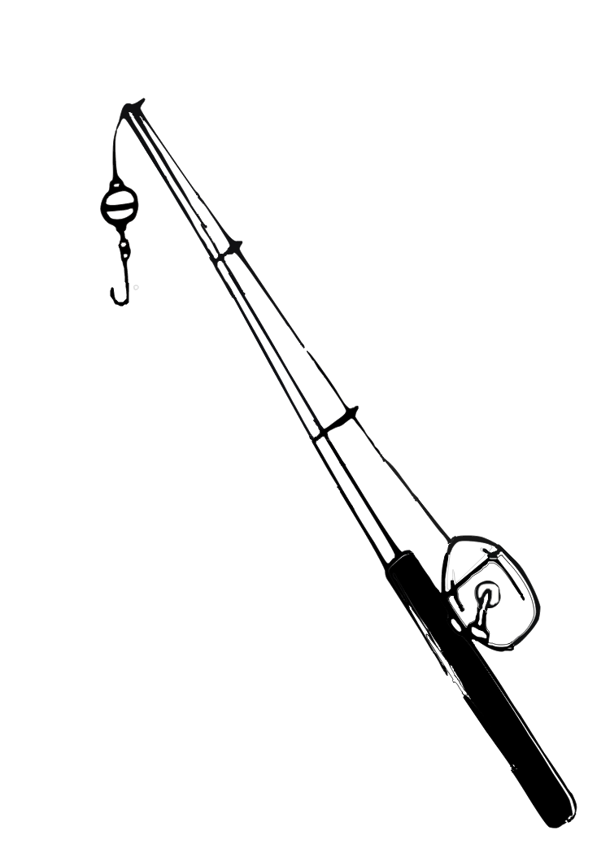

COMS W4735: Visual Interfaces to Computers

Assignment 2

due: 3/17/2015

Nina Baculinao

uni: nb2406

# Introduction

The goal of the Visual Information Retrieval system is to explore different ways of deciding the degree of similarities between actual images. It primarily looks at color, texture, similarity as a linear sum of ratios between the two, and clustering. Finally, the system is evaluated against the more intelligent baseline of human judgment to see how it performs.

Images analyzed in this project had the following properties:

* PPM format (versus lossier JPEG versions)
* 89 x 60 pixels
* 01-40 numbering sequence

Hardware and library specifications of this project are as follows:

* MacBook Air 11 inch running on OSX Yosemite
* Python Standard Library 2.7.9
* OpenCV with a Python binding, v2.4.10.1
* NumPy 1.9.1
* Matplotlib 1.4.2

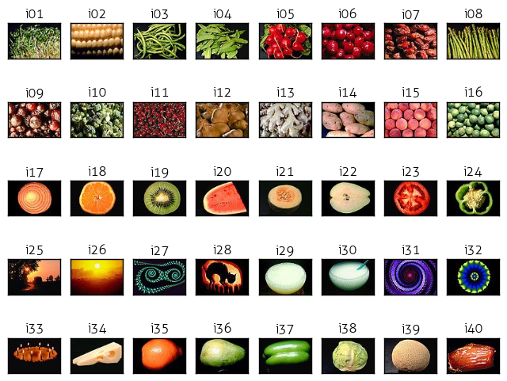

*Figure 1.* All the images analyzed by the system

*Note:* the display on the previous page was generated with matplotlib using the following code snippet. While the learning curve for matplotlib is a bit steep, its ability to plot images and graph figures along various axes, rows and columns was very useful.

**def** display_all(images, titles):

plt.rcParams['font.family']='Aller Light'

**for** i **in** xrange(NUM_IM):

plt.subplot(5,8,i+1),plt.imshow(cv2.cvtColor(images[i], cv2.COLOR_BGR2RGB))

plt.title(titles[i], size=12)

plt.xticks([]),plt.yticks([])

title = './all_im.png'

plt.savefig(title, bbox_inches='tight')

**print** title

Gross Color Matching

## Overview

The algorithm to compare images strictly on their total color distribution is described in broad steps directly below, and in more detail following this general description.

1. For each image in the directory:
   1. Load the image with OpenCV2 (and append to a list)
   2. Generate a color histogram for the image (and append to a list)
   3. *Optional*: Visualize the histogram as a bar graph (and append to a list)
2. Calculate the distance between every image pair (and store in a lookup dictionary)
   1. Use the histograms values of each image pair to determine the L1 norm
3. For each image:
   1. Determine the three images *most like it* and the three images *most unlike it* in terms of color distribution
   2. Display the septuples: original, three alike, three unalike
4. Determine group of four *most alike* images and group of four *most unalike* images
   1. Display the two groups of four: most alike, most unalike

## 

## Bin Size

The chosen bin size and black threshold for my program are as follows:

COL_RANGE = 256

BLK_THRESH = 40

BINS = 8

BIN_SIZE = int(COL_RANGE/BINS)

BLK_THRESH = 40

Because there are 256 RGB possible values in each color pixel, giving each color value a separate bin would make generating a histogram unfeasible because that would be accounting for ~16 million bins! Not to mention, there would certainly be a scarcity of data for each bin. Therefore, it was critical to determine a good size for clustering color values that would still capture the color distribution of an image histogram within decent runtime. As can be expected, I was inclined toward testing values to the power of 2. While it is true that the color histograms generated with 16 and 32 bins had a wider and more diverse array of color bars compared to the histogram visuals (on the following page), I found out that I got very comparable results for best matching images and final septuple of color matching, whether I chose 8, 16 or 32 bins. Therefore I decided 8 was good enough, and fast enough. There were still 8x8x8 = 512 possible bins for the RGB values to go!

## Black Threshold

The black threshold was another important decision to be made, as several images had black backgrounds, and could results in false negative color matches if the histogram matched similar black background content of say, an orange, with a kiwi.

|  |  |  |  |  |  |  |  |  |  |
| --- | --- | --- | --- | --- | --- | --- | --- | --- | --- |
| R: 0  G: 0  B: 0 | 10  10  10 | 20  20  20 | 30  30  30 | 40  40  40 | 50  50  50 | 60  60  60 | 70  70  70 | 80  80  80 | 90  90  90 |

*Figure 2.* Color bar showing range of RGB values. 40,40,40 still looks black, right?

After printing out the numpy array and surveying the black, I determined with my human eyes as a baseline that values under 40, 40, 40 are hard to discern as other than black. Is it just me? A possible influence for my low sensitivity to black color may be due to the fact that I like to do computer work with flux on and low brightness.

Therefore, after laying down the law with a black threshold of 40, I created a condition in my color_histogram function to bar all black and near-black pixels from taking a coveted spot in my histogram. The if condition is as follows, where I check the pixel before adding to histogram whether *all* of its RGB values are over 40:

**if** pixel[0] > BLK_THRESH **and** pixel[1] > BLK_THRESH **and** pixel[2] > BLK_THRESH:

## Color Histogram

The histogram calculations are computed without the aid of any black box algorithms. While OpenCV does have the cv2.compareHist function and SciPy also comes with its own distance metrics, implementing a 3D color histogram is actually quite simple, as can be seen in my code fragment below:

**def** color_histogram(image, title):

*'''*

*Calculate the 3D color histogram of an image by counting the number*

*of RGB values in a set number of bins*

*image -- pre-loaded image using cv2.imread function*

*title -- image title*

*(optional: visualize the histogram as a bar graph)*

*'''*

colors = []

h = len(image)

w = len(image[0])

*# Create a 3D array - if BINS is 8, there are 8^3 = 512 total bins*

hist = np.zeros(shape=(BINS, BINS, BINS))

*# Traverse each pixel in the image matrix and increment the appropriate*

*# hist[r_bin][g_bin][b_bin] - we know which one by floor dividing the*

*# original RGB values / BIN_SIZE*

**for** i **in** xrange(h):

**for** j **in** xrange(w):

pixel = image[i][j]

*# If the pixel is below the black threshold, do not count it*

*# Also note: pixel[i] is descending since OpenCV loads BGR*

**if** pixel[0] > BLK_THRESH **and** pixel[1] > BLK_THRESH \

**and** pixel[2] > BLK_THRESH:

r_bin = pixel[2] / BIN_SIZE

g_bin = pixel[1] / BIN_SIZE

b_bin = pixel[0] / BIN_SIZE

hist[r_bin][g_bin][b_bin] += 1

*# Generate list of color keys for visualization*

**if** (r_bin,g_bin,b_bin) **not** **in** colors:

colors.append( (r_bin,g_bin,b_bin) )

*# plot = visualize_chist(image, hist, colors, title)*

*# return plot, hist*

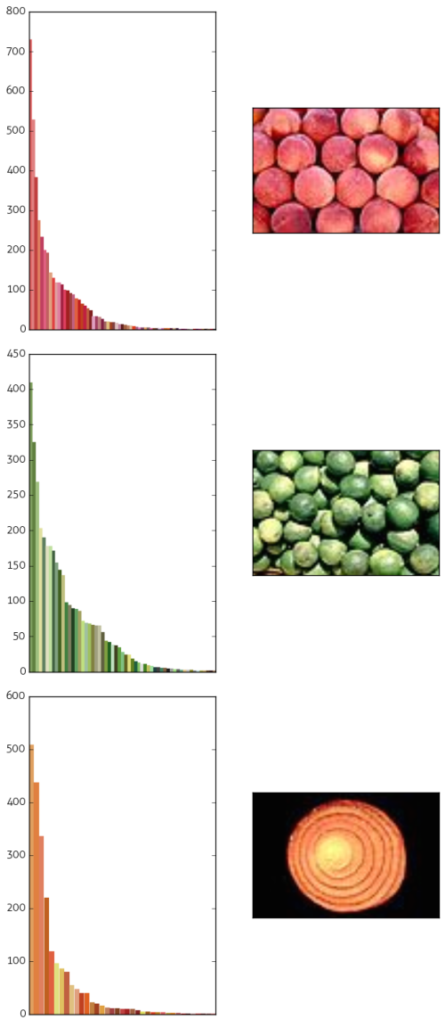 **return** hist

## Important decisions in this step included selection of the **BINS** and **BLK_THRESH**, which I already discussed.

## You might notice that the invocation for the **visualize_chist** function is commented out. That is because writing and generating every single figure takes about a little bit of extra runtime, and once I saved the images to a folder, I do not really need to produce the bar graphs again again. The **visualize_chist** function invokes matplotlib to plot a bar graph for the histogram, so it’s a lot of boilerplate, but the key to it lies in this line:

colors = sorted(colors, key=**lambda** c:

-hist[(c[0])][(c[1])][(c[2])])

## **colors** is the list of RGB color tuples from the **color_histogram** method, and this line re-sorts it from the highest count for that tuple in the histogram to the lowest count. Then it uses the following helper function:

**def** hexencode(rgb, factor):

*"""Convert RGB tuple to hexadecimal color code."""*

r = rgb[0]*factor

g = rgb[1]*factor

b = rgb[2]*factor

**return** '#**%02x%02x%02x**' % (r,g,b)

## to create the color hex string for displaying the bar graph. Example output can be seen on the right.

*Figure 3.* Histograms for images: i15, i16, and i17. Note that black pixels are not counted.

## Color Similarity and Distance

To calculate the relative similarity or distances between a pair of images, I used the suggested L1_norm as discussed in class. In my particular implementation, I considered the norm (or distance) for two images to be:

L1_norm = ∑ (differences) / ∑ (pixel count)

where

L1_norm = distance = 1 – similarity

or you could say

similarity = 1 – distance = 1 – L1_norm

Since it is very easy to convert between similarity and distance, and I found it more intuitive to work with distances than similarities, looking for images with “shorter distances” and closer to 0, I generally tended to use a list of distance values in my code. However, for the sake of human readability and because we often talked of similarity measures in class and in discussions of this assignment, I printed similarity values for the septuple captions for my color matches.

My simple implementation is below:

**def** l1_color_norm(h1, h2):

diff = 0

total = 0

**for** r **in** xrange(0, BINS):

**for** g **in** xrange(0, BINS):

**for** b **in** range(0, BINS):

diff += abs(h1[r][g][b] - h2[r][g][b])

total += h1[r][g][b] + h2[r][g][b]

l1_norm = diff / 2.0 / total

similarity = 1 - l1_norm

**return** l1_norm

For constant time lookup, I decided to calculate all possible pairwise distances between images and store them in a lookup table called chist_dis.

**def** calc_cdistance(chists):

chist_dis = {}

**for** i **in** xrange(NUM_IM):

**for** j **in** xrange(i, NUM_IM):

**if** (i,j) **not** **in** chist_dis:

d = l1_color_norm(chists[i], chists[j])

chist_dis[(i,j)] = d

**return** chist_dis

## Septuple of Three Best and Three Worst Matches

The existence of my lookup table for every pair made finding the three best and three worst color matches quite efficient. The function below takes in one image, and compares it to every other image in the image set, then sorts their distances in a list by smallest to greatest distance, returning the first three items (the best matches) and the last three items (the worst matches) in the list. Within my main method, I run color_matches for all 40 images to generate 40 septuple sets.

**def** color_matches(k, chist_dis):

*"""*

*Find images most like and unlike an image based on color distribution.*

*k -- the original image for comparison*

*chists -- the list of color histograms for analysis*

*"""*

results = {}

indices = []

distances = []

**for** i **in** xrange(0, NUM_IM):

**if** k > i: *# because tuples always begin with lower index*

results[i] = chist_dis[(i,k)]

**else**:

results[i] = chist_dis[(k,i)]

*# Ordered list of tuples (dist, idx) from most to least similar*

*# -- first value will be the original image with diff of 0*

results = sorted([(v, k) **for** (k, v) **in** results.items()])

*# print 'results for image', k, results*

seven = results[:4]

seven.extend(results[-3:])

distances, indices = zip(*seven)

**return** indices, distances

Here is an example of my output. Full results can be found at the end of this section and the full list with color histograms + image septuples appears in the appendix appendix.

|  |  |  |  |  |  |  |
| --- | --- | --- | --- | --- | --- | --- |
| Original | Most Like | 2nd Most Like | 3rd Most Like | 3rd Most Unlike | 2nd Most Unlike | Most Unlike |

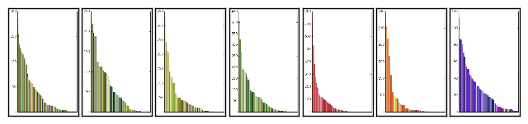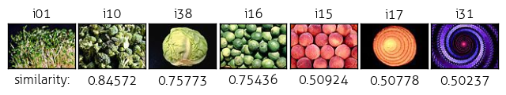

*Figure 4.* Septuple of three most alike images and three most unlike images to original

## Group of Four “Most Alike” and “Most Unlike”

It was here that I had to adjust my original plan/algorithm because of low performance for selecting the “Four Most Unlike” images. Originally I just picked my group of four my collection septuples. I would look at the original image plus its three doppelgangers or the original image plus its three anti0images, and consider that a valid candidae for the “group of four.” From these lists, I took the four most alike with lowest combined sum for distance, and four most unalike with highest combined sum for distance. The approach returned to me gave me was “matching set” for i01.ppm (good) and “unmatching set” for i03.ppm (not so good – as you can see in the first column).

This lazy and naïve strategy was fine for the most alike set, but backfired for the most different set because as you can see i06 and i15 are quite close to each other in terms of color and are in the same set because both oppose green beans. I ended up storing all combinations of four as a combination of distances between *every single pair* in the group, and then picking the group with the greatest distance. In the better results, there nothing matches i15. Results and implementation below.[1]

*Figure 5:* Not-So-Good: Alike, Unalike Better Results: Alike, Unalike

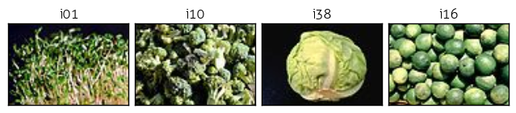 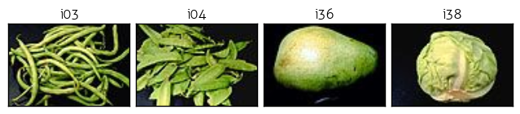

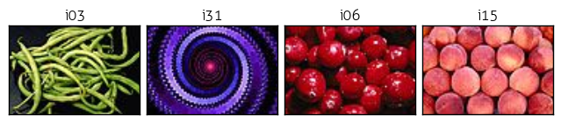 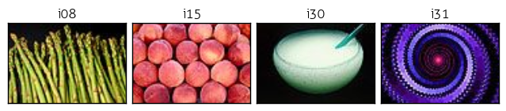

**def** find_four(chist_dis):

results = {}

*# ensure that a<b, b<c and c<d as order does not matter*

**for** a **in** xrange(NUM_IM):

**for** b **in** xrange(a+1,NUM_IM):

**for** c **in** xrange(b+1,NUM_IM):

**for** d **in** xrange(c+1,NUM_IM):

results[(a,b,c,d)] = \

chist_dis[(a,b)] + chist_dis[(a,c)] + \

chist_dis[(a,d)] + chist_dis[(b,c)] + \

chist_dis[(b,d)] + chist_dis[(c,d)]

results = sorted([(v, k) **for** (k, v) **in** results.items()])

best = results[0]

worst = results[-1]

indices = list(best[1])

indices.extend(list(worst[1]))

**return** indices

## Full Results

### Four Best Match: Four Worst Match:



### Image Septuples

|  |  |  |  |  |  |  |
| --- | --- | --- | --- | --- | --- | --- |
| Original | Most Like | 2nd Most Like | 3rd Most Like | 3rd Most Unlike | 2nd Most Unlike | Most Unlike |



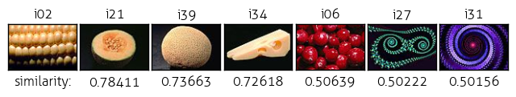

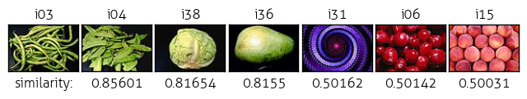

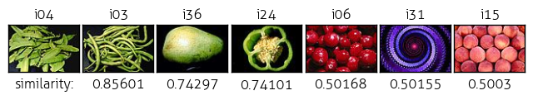

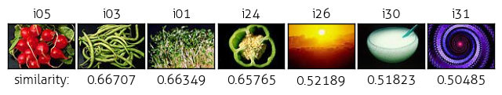

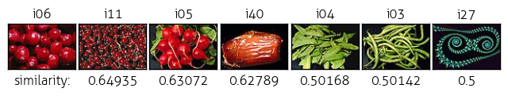

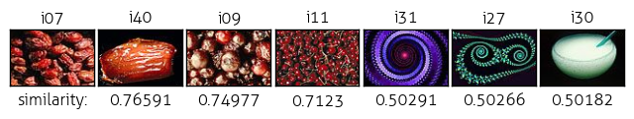

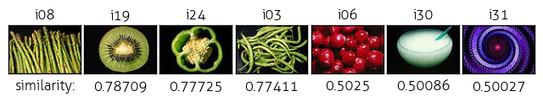

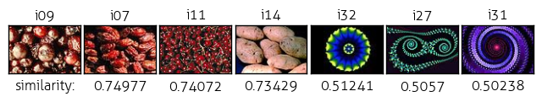

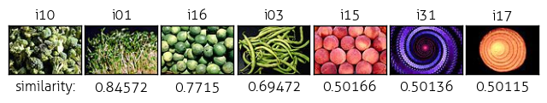

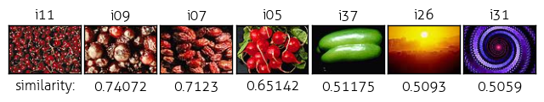

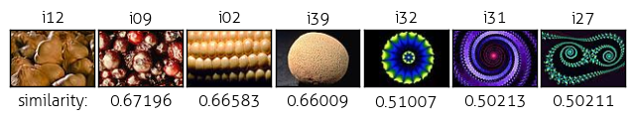

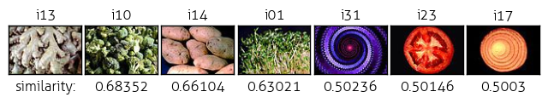

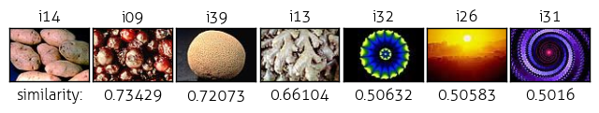

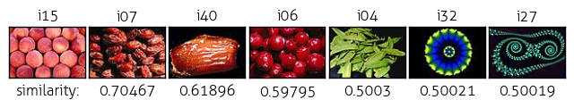

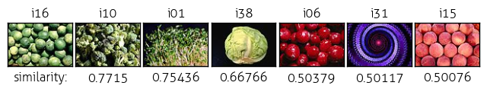

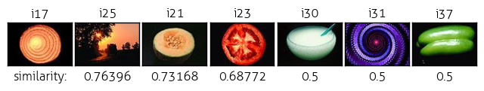

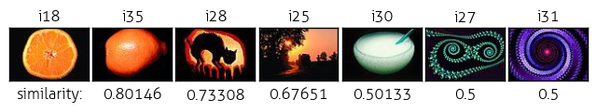

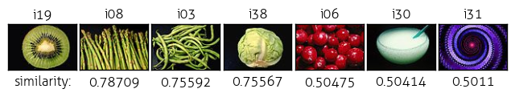

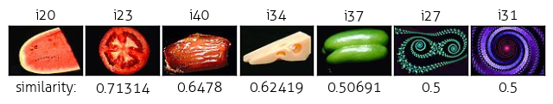

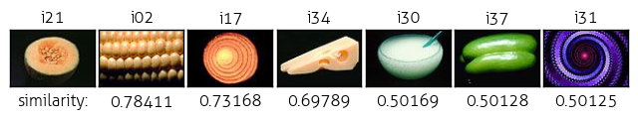

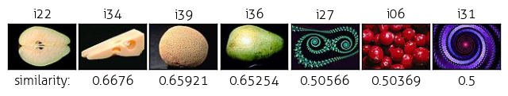

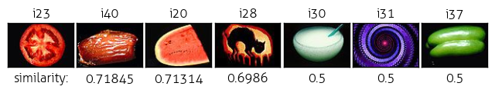

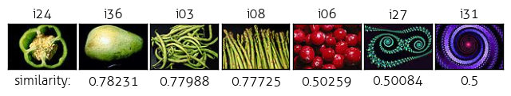

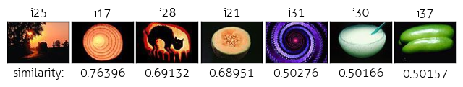

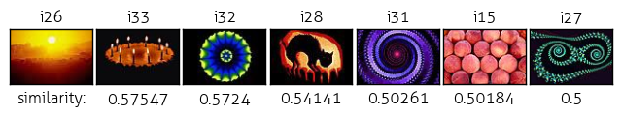

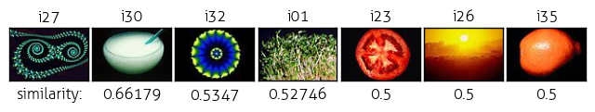

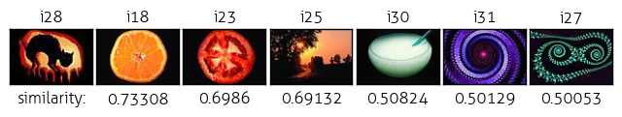

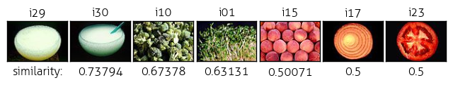

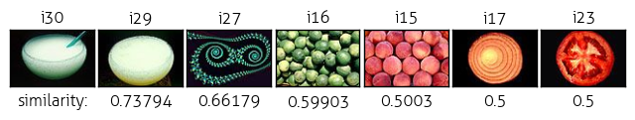

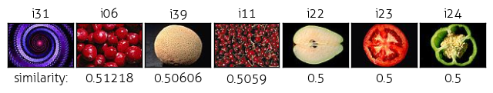

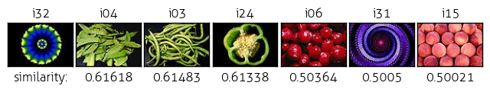

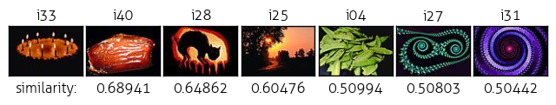

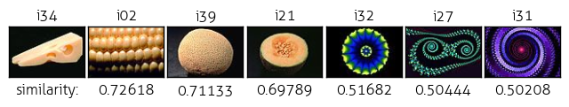

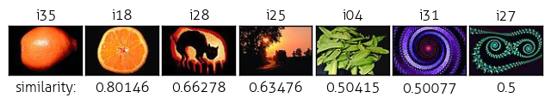

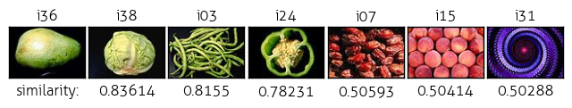

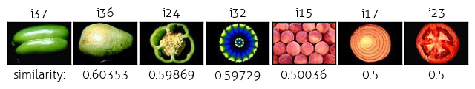

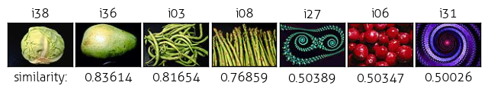

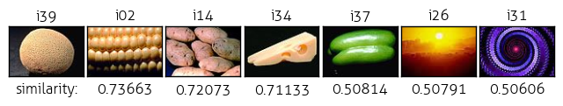

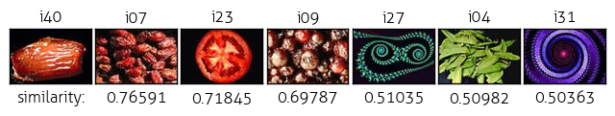

Gross Texture Matching

## Overview

The algorithm to compare images strictly on their total ‘edginess’ distribution, or in other words texture, is very similar to my color matching algorithm above, with a few notable differences.

1. For each image in the directory:
   1. Load the image with OpenCV2 (and append to a list)
   2. **Convert to grayscale image**
   3. **Convert to Laplacian image**
   4. **Generate a 1D histogram based on the Laplacian image, which is calculated for each pixel by multiplying that pixel’s value by the number of neighbors and subtracting the sum of its neighbors pixels** (and append that to a list)
   5. *Optional*: Visualize the histogram as a bar graph (and append to a list)
      1. This actually looked really bad
2. Calculate the distance between every image pair (and store in a lookup dictionary)
   1. Use the histograms values of each image pair to determine the L1 norm
3. For each image:
   1. Determine the three images *most like it* and the three images *most unlike it* in terms of **edginess** distribution
   2. Display the septuples: original, three alike, three unalike
4. Determine group of four *most alike* images and group of four *most unalike* images
   1. Display the two groups of four: most alike, most unalike

All that gray stuff I already did. The differences in these algorithms however are notable, because they are very different ways to gauge the similarity between two images. Before, we looked at color distribution. Now, we look away from the color and at measures of “edginess.” Because of this difference, I had to reassess my existing constants for bin size and black threshold, and consider new bin sizes and new thresholds for the Laplacian image.

## 

## Bin Size

Below are the bin size I decided on for my Laplacian image.

BLK_THRESH = 40

LAP_BINS = 128

LAP_BIN_SZ = int(COL_RANGE*8)/LAP_BINS

In the process of finding the edge distribution in an image, the first step was to make the image grayscale – that is, divide each RGB value by 3 and reduce it to a 1D histogram later. The was a simple matter, as you can see from the code below.

**def** grayscale(image, title):

*"""Convert image into black and white with (R+G+B)/3"""*

gray = np.zeros(shape=(IMG_H, IMG_W))

**for** row **in** xrange(IMG_H):

**for** col **in** xrange(IMG_W):

*# compose gray image pixel by pixel*

pixel = image[row][col]

rgb = int(pixel[0]) + int(pixel[1]) + int(pixel[2])

g = int(round((rgb / 3.0),0)) *# round up*

gray[row][col] = g

*# gray_img = cv2.imread(gray, cv2.IMREAD_UNCHANGED)*

cv2.imwrite('./gray/'+title+'.png', gray)

**return** gray

Since I no longer had to worry about a cubic order of growth for Laplacian bin size as we were dealing with a 1D and no longer a 3D histogram, but still felt no need to sample all of the 256 range, I settled for a Laplacian bin size of 128. Through trial and error, I had realized that my original bin size of 8 was far too small, so I was happy with the final results after much tweaking with the Laplacian bin size and dealing with the black background in various ways.

## Black Threshold

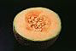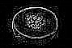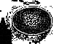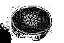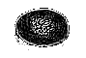

blk thresh: 0 15 20 40

Dealing with the black background in this instance was involved trial and error as well. As you can see in the transformations above, these are the Laplacian transformations depending on black threshold. A threshold of 0 maintains the black background, whereas a threshold of 15 was too little and still kept black edges in the corner. I ended up staying with my original black threshold of 40, which makes sense as before I was making sure every RGB value was above 40 before including it in the histogram – here, since I had already divided RGB by 3 for to make the image grayscale, so comparing it to the cutoff of 40 once makes sense. The other choice I made was not to remove the black pixels when I made the grayscale or laplacian image. That was because I planned to save the laplacian image, and I didn’t like the white background, and furthermore thought that might bring additional complications – which I tried actually, and it did you – you can see the commented out code down below. Instead, I treated the black threshold in the same was as my color histogram – when generating my 1D texture histogram, I only added the pixel count to the histogram if that gray pixel was above the black threshold.

**def** texture_histogram(lap, gray, title):

hist = np.zeros(shape=LAP_BINS)

bins = []

**for** i **in** range(IMG_H):

**for** j **in** range(IMG_W):

pixel = lap[i][j]

*# Only count pixels outside the black threshold*

*# to avoid image similarity due to shared black background*

**if** gray[i][j] > BLK_THRESH:

**if** pixel < 256:

bin = abs(pixel/LAP_BIN_SZ)

hist[bin] += 1

**if** bin **not** **in** bins:

bins.append(bin)

*# plot = visualize_thist(gray, hist, bins, title)*

*# print 'hist', hist*

*# return hist, plot*

**return** hist

## Laplacian Image

The sum of the Laplacian image following the grayscale conversion is an interesting measuring point. To generate the laplacian image, I create a new numpy array of 0s, and replace each original gray pixel with the formula:

lapl_pixel = gray_pixel * num_of(neighbors) / ∑ (neighboring pixels)

|  |  |  |  |  |  |  |
| --- | --- | --- | --- | --- | --- | --- |
| (i-1,j-1) | (i-1,j) | (i-1,j+1) |  | Top left | Top center | Top right |
| (i,j-1) | (i,j) | (i,j+1) | i21 pixels | Center right | Center | Center left |
| (i+1,j-1) | (i+1,j) | (i+1,j+1) |  | Bottom right | Bottom center | Bottom left |

**def** laplacian(gray, title):

*"""Make laplacian image by calculating sum of neighbors for every pixel"""*

*# gray = grayscale(image)*

laplacian = np.zeros(shape=(IMG_H, IMG_W))

*# laplacian.fill(COL_RANGE) # white would be 255+255+255/3 = 255*

**for** i **in** xrange(0,IMG_H):

**for** j **in** xrange(0,IMG_W):

*# if gray[i][j] > int(BLK_THRESH/2):*

**if** gray[i][j]:

neighbors = []

**for** row **in** xrange(i-1,i+2):

**for** col **in** xrange(j-1,j+2):

**if** **not** (row **is** i **and** col **is** j) **and** index_valid(row,col):

neighbors.append(gray[row][col])

neighbor_sum = reduce(**lambda** x, y: x+y, neighbors)

n = len(neighbors)

laplacian[i][j] = gray[i][j]*n - neighbor_sum

*# print 'laplacian',laplacian*

cv2.imwrite('./laplacian/'+title+'.png', laplacian)

**return** laplacian

**def** index_valid(row,col):

**if** (row < 0 **or** col < 0 **or** row >= IMG_H **or** col >= IMG_W):

**return** False

**return** True

The is near 0 values where there are homogenous colors (black in the pictures below, gray in the matplotlib display values as you can see in Appendix C), and traced edges.

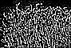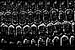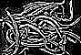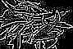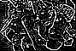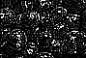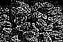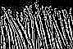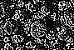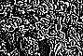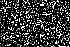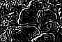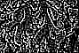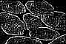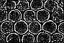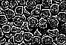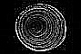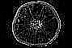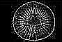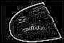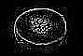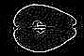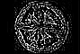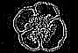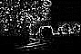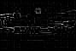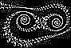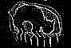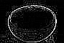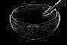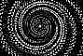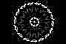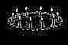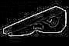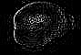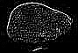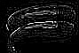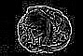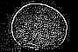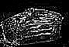

One thing I noticed when trying to match texture histograms and analyzing the results is that the similarity between objects is often quite high. For instance, all these closely matching values are above 96%. The least similarity generally does not drop below 60%. The edge detection seems to work quite well however. Here we can see potatos grouped with corn and some other small round root plant. As these items are all round and bulbous, regardless of their proximity to size, their texture certain seems yo match quite well.

## 

## 

## 

I also tried to account for more adjustments like changing the black threshold, and fiddling with the Laplacian bin size, but the images have tended to stay in that range, with 0.6% similarity considered very far. This is a good thing, although I wish the metric would be more sensitive to difference and distance between images.

As you can see in this example, which is even clearer in the bottomost Laplacian image, the clustering of the corn kernels matches the porous potatos and the little peaches(?) in i15 and mushrooms(?) in i12. I am surprised that the mushrooms aren’t a closer match to the potatoes than the corn, seeing as they are similar in size from the vantage of the thumbnail, while the corn texture is more tightly clustered. The sunset is almost completely devoid of edges, which makes sense that it is considered unlike the other images.

## Results

### Four Best Match: Four Worst Match:

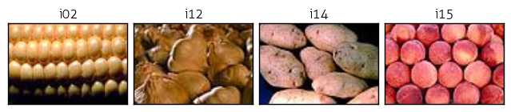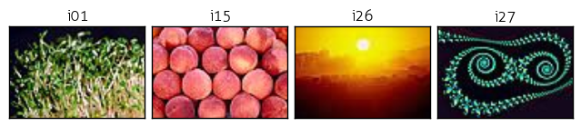

### Image Septuples:

|  |  |  |  |  |  |  |
| --- | --- | --- | --- | --- | --- | --- |
| Original | Most Like | 2nd Most Like | 3rd Most Like | 3rd Most Unlike | 2nd Most Unlike | Most Unlike |

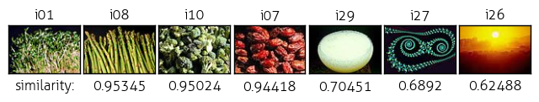

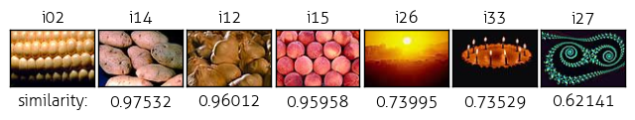

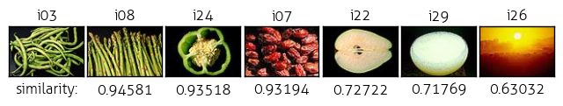

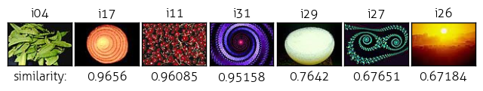

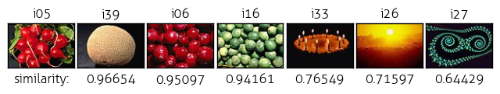

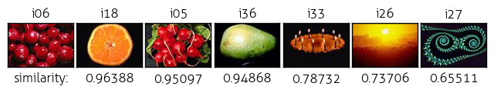

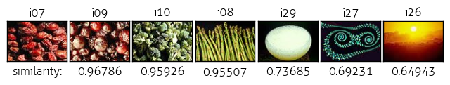

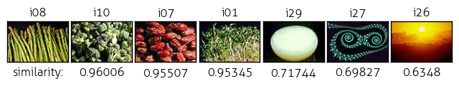

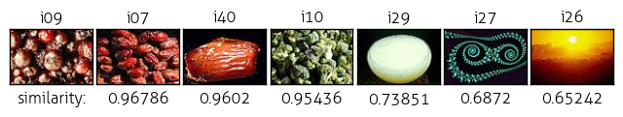

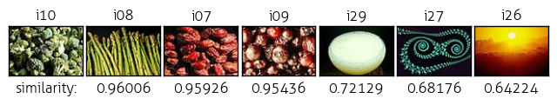

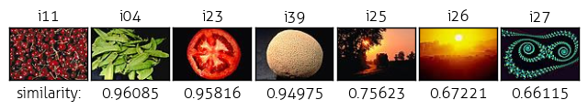

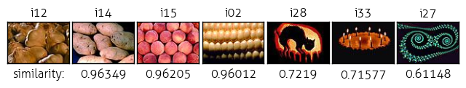

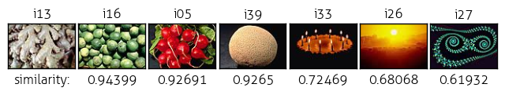

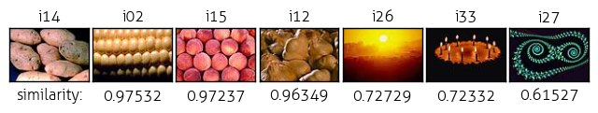

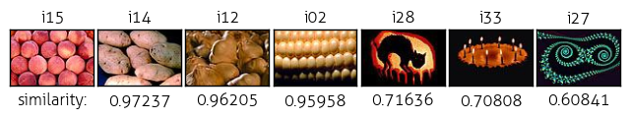

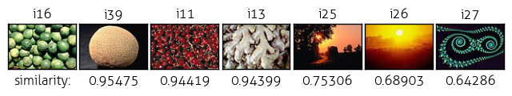

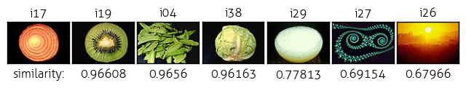

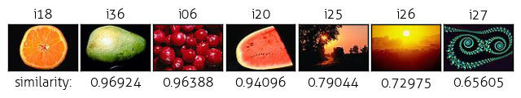

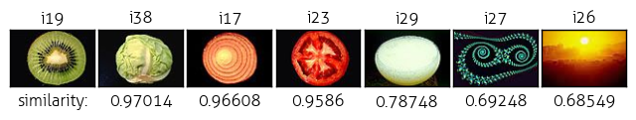

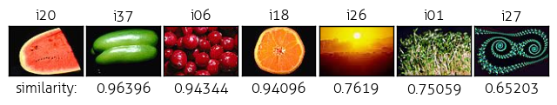

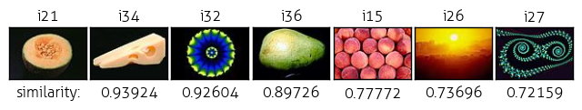

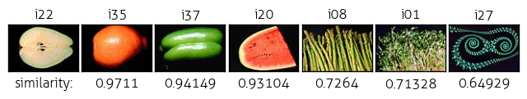

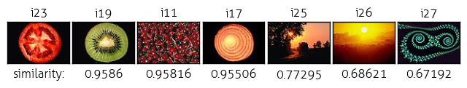

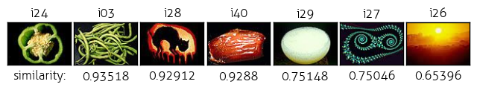

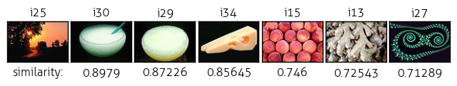

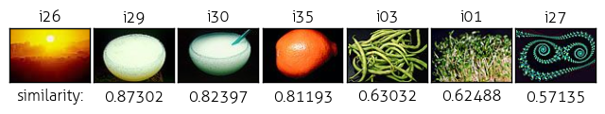

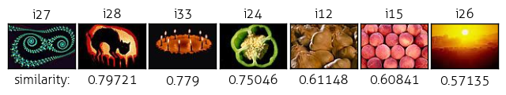

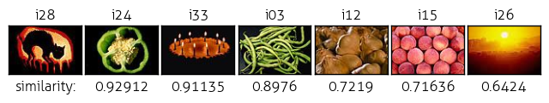

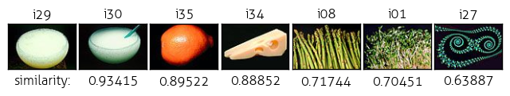

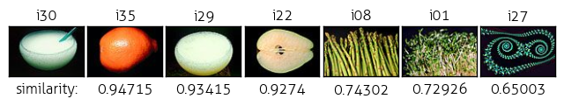

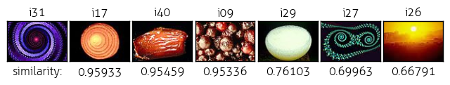

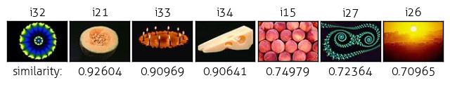

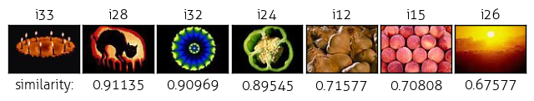

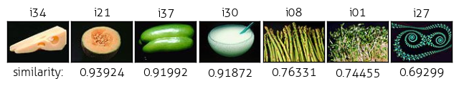

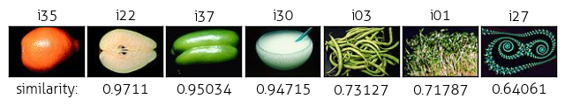

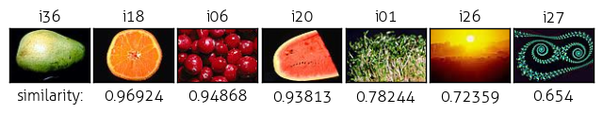

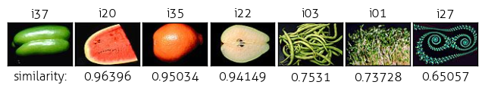

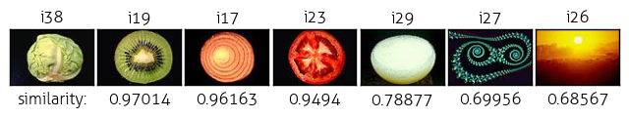

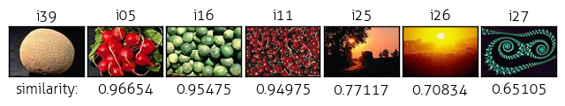

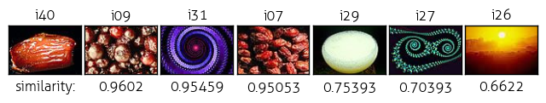

## Combine Similarities, and Cluster

For this part, the linear sum for combined similarity is as follows:

combined_similarity = r * (t_sim) + (1 –r)*(c_sim)

where I tested several values of the ratio r. I tested primarily by checking out how different values of r would change the most alike and most unalike group of four, and also comparing the clustering results for single link and complete link clustering.

## Similarity Measure

The code below is a bit roundabout, because it is a similarity measure, but at the same time I have been using distance measures throughout so I ended up converted the distances to similarities, then converting that combined similarity back to distances. Using distances was also much more intuitive and convenient for the clustering method.

**def** combine_similarities(chist_dis, thist_dis):

similarities = {}

distances = {}

closest = 1

r = 0.5

**for** i **in** xrange(NUM_IM):

**for** j **in** xrange(i+1, NUM_IM):

**if** (i,j) **not** **in** similarities:

t_sim = 1 - thist_dis[(i,j)]

c_sim = 1 - chist_dis[(i,j)]

s = r*(t_sim) + (1-r)*(c_sim)

d = 1 - s

*# d = r*thist_dis[(i,j)] + (1-r)*chist_dis[(i,j)]*

similarities[(i,j)] = s

distances[(i,j)] = d

*# if (d < closest):*

*# closest = (i,j)*

**return** similarities, distances*#, closest*

## Combined Similarity Results

|  |  |
| --- | --- |
| Most Alike | Most Unalike |
|  |  |
| r = 0, all color |  |
|  |  |
| r = 0.2, mostly color |  |
|  |  |
| r = 0.5, half half |  |
|  |  |
| r = 0.8, mostly texture |  |
|  |  |
| r = 1, all texture |  |

## As the lynchpins, I included the group of four based wholly on texture and wholly on color on either ends of the comparison of r values here. It appears that image i07 and i26 are very different texture wise (the former being very uniquely textures and the latter having nerly no texture at all), so they are mainstays. Oddly enough, and surprised I didn’t notice this before, the round plums are both in the group of four most alike and most unalike.

## At any rate, since it is harder to gauge how “unlike” two images are, for me at least, I looked mainly at the “alike” set to consider which r is better. While I originally first tested a value of r = 0.2 because I considered color to be far more important to my conception of visual similarity than texture, it turns out that the flip end r = 0.8 has better alike results. While it is easy to match items based on color similarity, texture turns out to be a good tiebreaker for differentiating those similar-color things.

## Complete Link vs. Single Link Clustering

To create the 7 clusters, I followed the assignment directives of using “complete link” and then “single link” to cluster the images. For both, all images begin in their own cluster or disjoint sets, and each pair is compared to find the nearest pair according to the new combined similarity. Since I had generated pairwise distances in that method already, I passed in the lookup table and just iterated through every cluster pair to find the nearest pair. The difference between complete link and single link comes when dealing with grouping multi-element clusters. In a complete link model, the “nearness” of wo clusters is the fartest distance between any 2 elements in those 2 clusters. In a single link model, the nearest distance between two elements in those clusters is what is considered the nearness

My implementation is on the next page.

**def** cluster(distances, link):

clusters = {}

**for** idx **in** xrange(0,NUM_IM):

clusters[(idx,)] = (idx,)

*# print clusters*

counter = 0

**while** len(clusters) > NUM_CLUSTERS:

nearest_pair = (None, None)

nearest_dist = 1 *# total dissimilarity*

counter += 1

*# Go through every cluster-pair to find nearest pair*

**for** a **in** clusters:

**for** b **in** clusters:

*# Do not compare with same cluster*

**if** a **is** **not** b:

dist = link

*# For each element in both clusters, determine "nearness"*

*# Complete nearness: farthest distance bt any 2 el in 2 clusters*

*# Single nearness: nearest distance bt any 2 el in 2 clusters*

**for** i **in** clusters[a]:

**for** j **in** clusters[b]:

k = (i,j)

**if** i > j:

k = (j,i) *# tuples always in ascending order*

curr_dist = distances[k]

**if** (link **is** 0 **and** curr_dist > dist) **or** \

(link **is** 1 **and** curr_dist < dist):

dist = curr_dist

*# Find out if this is the nearest pair so far in the iteration*

**if** dist < nearest_dist:

nearest_dist = dist

nearest_pair = (a,b)

nearest_pair_values = clusters[a]+clusters[b]

*# combine the nearest pair of clusters and remove old clusters*

clusters.pop(nearest_pair[0])

clusters.pop(nearest_pair[1])

*# new_pair = nearest_pair[0] + nearest_pair[1]*

clusters[nearest_pair_values] = nearest_pair_values

*# clusters[new_pair] = clusters[new_pair]*

**print** counter, clusters.keys()

*# print clusters*

clusters = clusters.keys()

**return** clusters

I had several false starts with storing the clustered values, but I finally was able to verify that this clustering code wotks by testing the small 4 element example provided in the assignment specification. I have included the console output of the clustering process and hope you find it illustrative to my method.

1 : New distance for (2,) (3,) 0 -> 0.4

1 : Replace distance with ((2,), (3,)) 1000 -> 0.4

1 : New distance for (2,) (1,) 0 -> 0.5

1 : New distance for (2,) (4,) 0 -> 0.6

1 : New distance for (3,) (2,) 0 -> 0.4

1 : New distance for (3,) (1,) 0 -> 0.1

1 : Replace distance with ((3,), (1,)) 0.4 -> 0.1

1 : New distance for (3,) (4,) 0 -> 0.3

1 : New distance for (1,) (2,) 0 -> 0.5

1 : New distance for (1,) (3,) 0 -> 0.1

1 : New distance for (1,) (4,) 0 -> 0.2

1 : New distance for (4,) (2,) 0 -> 0.6

1 : New distance for (4,) (3,) 0 -> 0.3

1 : New distance for (4,) (1,) 0 -> 0.2

1 [(2,), (3, 1), (4,)]

2 : New distance for (2,) (3, 1) 0 -> 0.4

2 : New distance for (2,) (3, 1) 0.4 -> 0.5

2 : Replace distance with ((2,), (3, 1)) 1000 -> 0.5

2 : New distance for (2,) (4,) 0 -> 0.6

2 : New distance for (3, 1) (2,) 0 -> 0.4

2 : New distance for (3, 1) (2,) 0.4 -> 0.5

2 : New distance for (3, 1) (4,) 0 -> 0.3

2 : Replace distance with ((3, 1), (4,)) 0.5 -> 0.3

2 : New distance for (4,) (2,) 0 -> 0.6

2 : New distance for (4,) (3, 1) 0 -> 0.3

2 [(2,), (3, 1, 4)]

3 : New distance for (2,) (3, 1, 4) 0 -> 0.4

3 : New distance for (2,) (3, 1, 4) 0.4 -> 0.5

3 : New distance for (2,) (3, 1, 4) 0.5 -> 0.6

3 : Replace distance with ((2,), (3, 1, 4)) 1000 -> 0.6

3 : New distance for (3, 1, 4) (2,) 0 -> 0.4

3 : New distance for (3, 1, 4) (2,) 0.4 -> 0.5

3 : New distance for (3, 1, 4) (2,) 0.5 -> 0.6

3 [(2, 3, 1, 4)]

[(2, 3, 1, 4)]

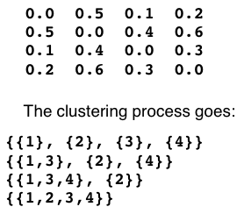

## Results with different r-values

As can be expected, the complete link at each step creates clusters that are cliques (every image is more related to every other image) whereas single link at each step, as the name suggests, link at one spot and grow like a minimum spanning tree. While before I said the value of r = 0.8 was more successful, in this case the cluster created by the combined similarity with r = 0.2 looks better, and r = 0.5 looks best. I say this because I cannot really discern the relationships between the images in the largest cluster in r = 0.8, possibly because they are dominated by texture and the images are so small in this particular display that I am relying mostly on color to group them myself.

With r = 0.2, it is easy to see the clusters in the complete link: red, vivid green, creamy and light green, orange, and the outliers: the weird green fractal, purple vortex and generic sunset. If this was a pure color match, the sunset would porbbaly be included, but it’s smoothness is enough to make it an outlier. As for the single link example, the images are indeed very small due to the long chain in the middle, but since the clusters were stored as arrays I believe they were appended to each other in a sequential fashion, which makes it convenient to view the single linkages between them: in this case a color spectrum from orange to yellow green to green and then two reds (which should be opposed to green, but appear to have the same globular shape).

r = 0.5 has similar results, notably the purple vortex has joined the shriveled plum due to their comparable texture, and no longer the outlier. I might even consider that cluster to be more successful than the r = 0.2 example. The complete link is in this case also better than the single link case, exhibiting the same clique (multi-connected, complete-linked) behavior. Another reason I might deem it more successful is that the groups are slightly more balanced in numbers. Something I noticed during my user study was that even though I didn’t set down any rules for clustering sizes, people tended to try to group the images in similar sizes and not leave outliers alone. If I were to improve my clustering algorithm, I would perhaps do that, balance out the membership sizes of the clusters and also possibly place outliers together.

The clustering results are included below.

## r = 0.2, when color dominates - complete link

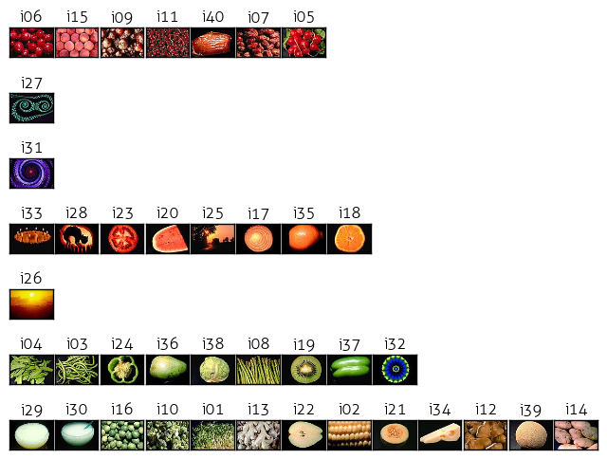

r = 0.2, single link

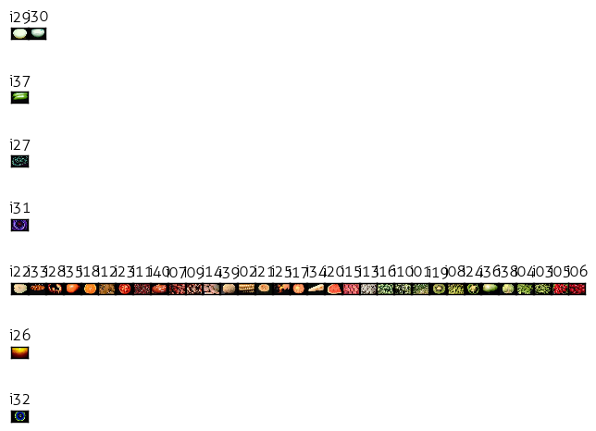

r = 0.5, compete link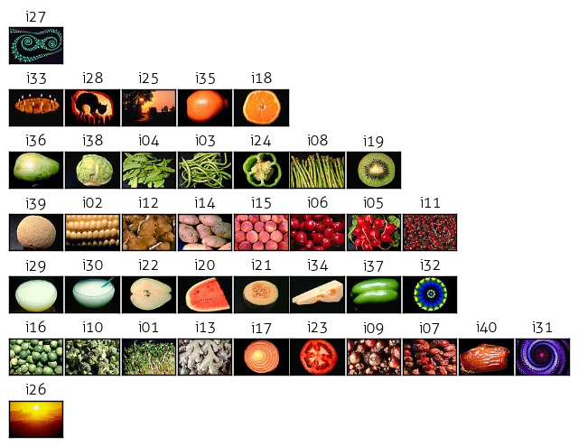

r = 0.5, single link

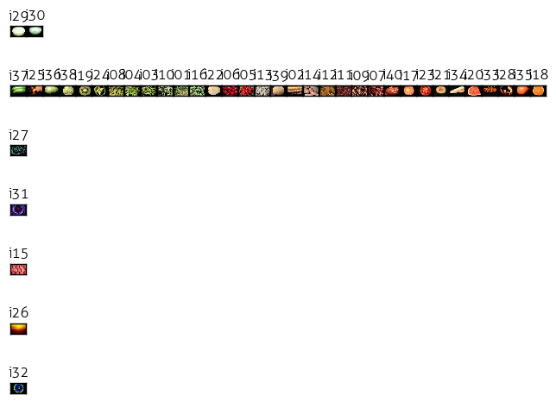

r = 0.8, complete link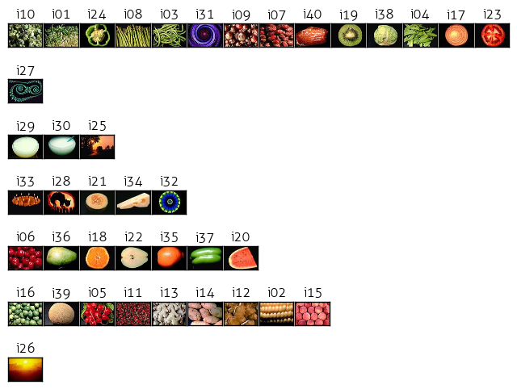

r = 0.8, single link 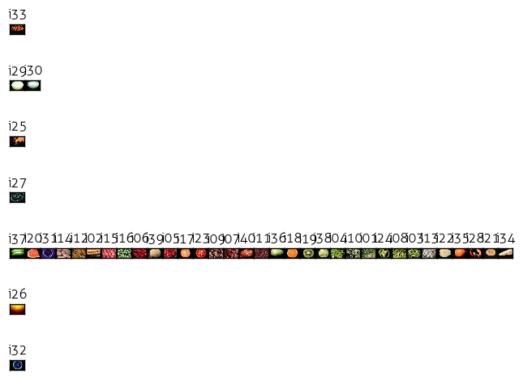

# Creative Step

## User Studies

For the final creative, evaluative step, I had some human users (ahem, four wonderful friends) match the best and worst image pairs by color and texture as an intelligent baseline against which I could measure my program’s performance.

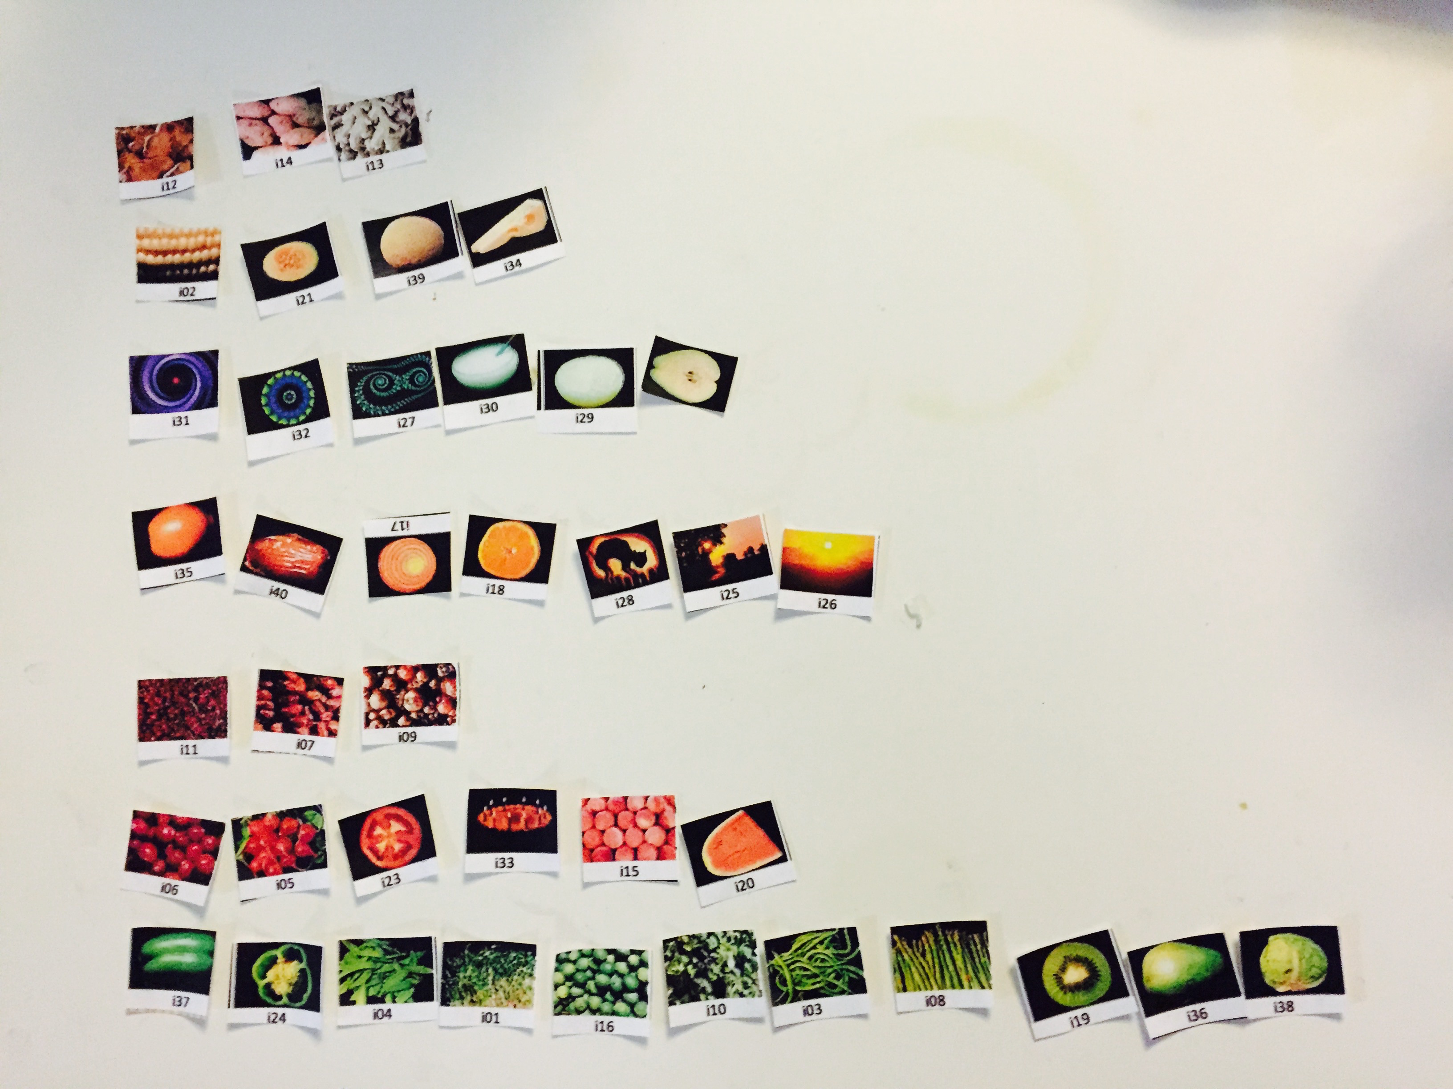

Funny note about human learning and knowledge sharing. The first of my willing users (Robert) took the longest time (over an hour), because he started from the beginning and answered the worst/best choices without organizing the pictures or clustering them. At the end, he commented that he wished he had done the clustering first. The next person, Jacky, finished much more quickly after doing clustering first in a more haphazard fashion (40 minutes). Alex, an artist, did clustering in a more organized fashion and finished in under 30 minutes. The photo above is his organized doing. Ashley, having seen everyone’s struggles and heard complaints about how tedious the tasks were, and for some reason intrigued by the study even though I told her I already had enough responses, managed to finish in about 15 minutes. Their answer sheets are filed in Appendix A.

## Performance Measure

To measure my system’s results against my friend’s decisions, I coded evaluation functions that took in the a human responses as a csv file, stored it as a list of values, and compared it to the system’s results for image matching and image clustering. To measure accuracy and performance, I took advantage (perhaps too freely) the handy measures of precision, recall, their F1 harmonic mean and the Rand index for clustering. The formulas are as follows (informally defined, as you can expect from me by now):

precision = tp / tp + fp

recall = tp / tp + fn

f1 = (2.0 * precision * recall) / (precision + recall)

rand_index = (tp + tn) / (tp + fp + fn + tn))

where

tp = true positive

fp = false positive

fn = false negtive

tn = true negative

measure different things depending on the evaluation. The two processes of evaluation and their respective results and discussed separately below.

## Matching Evaluation

The matching evaluation considers these cases:

|  |
| --- |
|  |
| tp -- if human guess is in sys results |
| fn -- if human guess is missing from sys results |
| fp -- if human guess is in opposite of sys results |
| And counts their occurrences for 1) best color match, 2) worst color match, 3) best texture match, and 4) worst texture match. tp is important as a measure of how many times the system can get a human results, fn is whever the system is missing a human answer in its top 3 candidates, and fp is the notable case that issues a print statement every time the condition is met – when a human says something is the worst/best match for something, but the system has placed it in the opposite best/worst match category. I use the numbers crunched by this function to evaluate the system performance and how accurately the computer can simulate human choices in visual matching. As input, the function takes in the previous color, texture results, and compares to the the specific entered indvidual’s answers for that category for every single image. Stay tuned, as I discuss how the system (and human!) performance after the break. |
|  |
|  |
| def match_eval(cresults, tresults, hresults): |
| # best,worst color and best,worst texture measures |
| bc_tp, bc_fp, bc_fn = 0,0,0 |
| wc_tp, wc_fp, wc_fn = 0,0,0 |
| bt_tp, bt_fp, bt_fn = 0,0,0 |
| wt_tp, wt_fp, wt_fn = 0,0,0 |
|  |
| counter = 0 |
|  |
| for i in xrange(0,NUM_IM*7,7): |
|  |
| # range indices for best/worst system results |
| b_from = i+1 |
| b_to = i+4 |
| w_from = i+4 |
| w_to = i+7 |
|  |
| # human results for best color, worst color, |
| # best texture, worst texture |
| # note: need var j because human list increments by 5 |
| # whereas system list increments by 7 |
| j = i - (2*counter) |
| c_best = hresults[j+1] |
| c_worst = hresults[j+2] |
| t_best = hresults[j+3] |
| t_worst = hresults[j+4] |
| counter += 1 |
|  |
| # check best color match |
| if c_best in cresults[b_from:b_to]: |
| bc_tp += 1 |
| else: |
| bc_fn += 1 |
| # since we are measuring computer against human perf: |
| # program messed up and made a big false positive |
| if c_best in cresults[w_from:w_to]: |
| wc_fp += 1 |
| print 'Human best color match in system worst!', cresults[i]+1, c_best+1  # +1 to make it readable - display current index and image in q |
|  |
| # check worst color match |
| if c_worst in cresults[w_from:w_to]: |
| wc_tp += 1 |
| else: |
| wc_fn += 1 |
| if c_worst in cresults[b_from:b_to]: |
| bc_fp += 1 |
| print'Human worst color match in system best!', cresults[i]+1, c_worst+1 |
|  |
| # check best texture match |
| if t_best in tresults[b_from:b_to]: |
| bt_tp += 1 |
| else: |
| bt_fn += 1 |
| # since we are measuring computer against human perf: |
| # program messed up and made a big false positive |
| if t_best in tresults[w_from:w_to]: |
| wt_fp += 1 |
| print 'Human best texture match in system worst!', cresults[i]+1,t_best+1 |
|  |
| # check worst texture match |
| if t_worst in tresults[w_from:w_to]: |
| wt_tp += 1 |
| else: |
| wt_fn += 1 |
| if t_worst in tresults[b_from:b_to]: |
| bt_fp += 1 |
| print'Human worst texture match in system best!', cresults[i]+1,t_worst+1 |
|  |
| # Calculate total tp,fp,fn values |
| tp = bc_tp + wc_tp + bt_tp + wt_tp |
| fp = bc_fp + wc_fp + bt_fp + wt_fp |
| fn = bc_fn + wc_fn + bt_fn + wt_fn |
|  |
| print "1: BEST COLOR MATCH RESULTS" |
| print_results(bc_tp, bc_fp, bc_fn) |
|  |
| print "2: WORST COLOR MATCH RESULTS" |
| print_results(wc_tp, wc_fp, wc_fn) |
|  |
| print "3: BEST TEXTURE MATCH RESULTS" |
| print_results(bt_tp, bt_fp, bt_fn) |
|  |
| print "4: WORST TEXTURE MATCH RESULTS" |
| print_results(wt_tp, wt_fp, wt_fn) |
|  |
| print "5: OVERALL COLOR AND TEXTURE MATCH RESULTS" |
| def print_results(tp, fp, fn): |
| print "TP: %d, FP: %d, FN: %d" % (tp, fp, fn) |
|  |
| precision = float(tp) / (tp + fp) |
| recall = float(tp) / (tp + fn) |
|  |
| print "Precision : %f" % precision |
| print "Recall : %f" % recall |
| print "F1 : %f" % ((2.0 * precision * recall) / (precision + recall)) |
|  |
|  |

## Matching Performance

Overall, the evaluation was written with the intention of comparing the system performance to human baselines. It is interesting to also compare the other way and consider how closely humans can approximate these computational decisions with their eyes and the differing performance and agreements between them.

While the numbers in precision are nice, it was hard to consider what might really be a “wrong” or “false positive” answer, which I considered to mean if the human and computer judgments of best/worst were completely at ends with each other. If there were no such cases as that, then precision was just a measure of tp/tp+0, which is 1 and perfect. Recall for closest match is an interesting thing to look at it, and it appears that only half the time the computer can guess what people would put as the closest or further color match, with better results for closest.

Since the F1 values can be seen as a mean between precision and recall (quality and quantity), we can see that generally there is more agreement for colors than textures.

Indeed, texture posed quite the pose for most of my friends, who kept asking me how they could feel the texture of a 2D image and how you were supposed to compare similar and further texture. Even more than colors, textures appear to be a subjective and ambiguous area of comparison. So in terms of performance, judging from the numbers in the table below, this seemed to be the trajectory of better to less better performance:

Color Best > Color Worst > Texture Best > Texture Worst

|  |  |  |  |  |  |  |  |  |
| --- | --- | --- | --- | --- | --- | --- | --- | --- |
|  | Robert |  | Jacky |  | Alex |  | Ashley |  |
| Color | Best | Worst | Best | Worst | Best | Worst | Best | Worst |
| Precision | 1.00000 | 0.94444 | 0.91667 | 1.00000 | 1.00000 | 0.83333 | 1.00000 | 1.00000 |
| Recall | 0.55000 | 0.42500 | 0.27500 | 0.15000 | 0.50000 | 0.25000 | 0.45000 | 0.22500 |
| F1 | 0.70968 | 0.58621 | 0.42308 | 0.26087 | 0.66667 | 0.38462 | 0.62069 | 0.36735 |
| Texture |  |  |  |  |  |  |  |  |
| Precision | 0.92308 | 0.89474 | 0.72727 | 1.00000 | 0.90909 | 0.92857 | 1.00000 | 0.70000 |
| Recall | 0.30000 | 0.42500 | 0.20000 | 0.20000 | 0.25000 | 0.32500 | 0.22500 | 0.17500 |
| F1 | 0.45283 | 0.57627 | 0.31373 | 0.33333 | 0.39216 | 0.48148 | 0.36735 | 0.28000 |

|  |  |  |  |  |
| --- | --- | --- | --- | --- |
| Overall | Robert | Jacky | Alex | Ashley |
| Precision | **0.94444** | **0.89189** | **0.92982** | **0.93478** |
| Recall | 0.42500 | 0.20625 | 0.33125 | 0.26875 |
| F1 | 0.58621 | 0.33503 | 0.48848 | 0.41748 |

Interesting to see how people come up with different subjective answers and the system compares to them. Generally however, the values seem quite consistent between this subset of four individuals, with an average harmonic F1 mean of 50% (not very good, but could be better if we increased the top three group to top five perhaps for the system, and also tweaked the algorithm).

Below are the major alarm points that set off the false positive alarm – when human best matches the system’s worst, or vice versa in some category. When I looked up the image indices, I had to agree that they were pretty confusing. Quickly, let’s go through them.

Human best match in system worst:

The purple vortex seems to be confusing in terms of color and texture. For 31, 27 and 32, 27, it seems natural that people see it as similar in texture to the other fractal looking images, but the system considers them the worst match for texture. Similarly, it seems hard to find a close color for purple , while people saw complementary purple and yellow, the system considred them the worst match.

Also interesting is that while people might consider two images to be the worst pair match, if they see the same two images again, they might not necessarily think that way. For i17 i29 and, the concentric circles might not be so apparent but for the system they are completely different textures. The 23 and 27 pairing may be a case of matching color instead of exture.

|  |  |
| --- | --- |
| Human best texture match in system worst! | Human worst texture match in system best! |
| 31 27 (2 people)    32 27 (2 people)    17 29    23 25 | 40 31 (3 people, Rob said 31 40)    22 37    38 19 |
| Human best color match in system worst! | Human worst color match in system best! |
| 32 31 (2 people)    31 22 | 31 6 |

For human worst match in system best:

In the top case on the right, three people said the worst match for texture was a shriveled date and the purple vortex – but the computer says it is the best. It could have to do with our associations – what does a dried fruit have to do with this geometric shape? Below that, the system considers the best match a sliced apple and green bellpepper, but for me at leas tthis gives opposing notions of inside and outside. Same with the wrinkled cabbage and seedy kiwi interior. In terms of color, the purple vortex strikes again, while one of my friends thought purple and red were the worst color match, the system though they were one of the best matches (possibly due to the lack of blue and purple in the image series and overabundance of green).

## Clustering Evaluation

Before I discuss ther results, let me briefly talk about my clustering performance measure. For the image clusters, I use the rand index, which I described a few pages up as

rand_index = (tp + tn) / (tp + fp + fn + tn))

In the case of this algorithm:

tp -- is defined as when a pair of images in the human result is in the same cluster, and the same pair of images is also in the same cluster in the system results

fp -- is when a pair of images share a cluster in the human groupings, but are in different clusters according to the system

fn -- is when the system clusters a pair of images, but the human has them in separate clusters

tn -- is when we consider a pair of images in different clusters in both the human and system results

The function takes in two lists of 7 tuples where each cluster is a tuple, one list generated by the system, the other by one of my friends. I wrote a helper function called cluster_id’s that unpacks each of the 40 image elements to different list indices and stores in the element their cluster/set number for easy lookup to determine whether two images belong in the same set (just check syst[i] and syst[j] for instance!)

Using the rand index, I can more objectively re-evaluate the r-value for the combined similarity complete clusters and determine which one might have better performance after all.

|  |
| --- |
| def cluster_eval(system, human): |
| # Change list of tuples -> list of lists |
| hum = cluster_id(human, 1) |
| syst = cluster_id(system, 0) |
|  |
| # Initialize True-Pos, True-Neg False-Pos, False-Neg measures |
| tp, tn, fp, fn = 0,0,0,0 |
| for i in xrange(NUM_IM): |
| for j in xrange(i+1,NUM_IM): |
| if hum[i] == hum[j] and syst[i] == syst[j]: |
| tp += 1 |
| if hum[i] == hum[j] and syst[i] != syst[j]: |
| fp += 1 |
| if hum[i] != hum[j] and syst[i] == syst[j]: |
| fn += 1 |
| if hum[i] != hum[j] and syst[i] != syst[j]: |
| tn += 1 |
| print "TP: %d, FP: %d, TN: %d, FN: %d" % (tp, fp, tn, fn) |
|  |
| rand_idx = (float(tp + tn) / (tp + fp + fn + tn)) |
| precision = float(tp) / (tp + fp) |
| recall = float(tp) / (tp + fn) |
|  |
| # Print results: |
| print "Rand index: %f" % rand_idx |
| print "Precision : %f" % precision |
| print "Recall : %f" % recall |
| print "F1 : %f" % ((2.0 * precision * recall) / (precision + recall)) |
|  |
| return rand_idx |

|  |
| --- |
| def cluster_id(list_of_tups, key): |
| ''' |
| Take list of cluster tups and return list of cluster id's |
| where each list index is the image and the el is its set id |
| key -- 1 if its starting index needs to be decremented to 0 |
| ''' |
| cluster_ids = [0] * 40 |
| for i in xrange(7): |
| tup = list_of_tups[i] |
| for j in tup: |
| if key is 1: |
| cluster_ids[j-1] = i |
| else: |
| cluster_ids[j] = i |
| return cluster_ids |

## Clustering Performance

|  |  |  |  |  |
| --- | --- | --- | --- | --- |
| r = 0.2 | Rob | Jacky | Alex | Ashley |
| Rand | **0.77692** | **0.78077** | **0.79103** | **0.77436** |
| Precision | 0.45455 | 0.46875 | 0.50000 | 0.44444 |
| Recall | 0.33742 | 0.36810 | 0.36810 | 0.31902 |
| F1 | 0.38732 | 0.41237 | 0.42403 | 0.37143 |
| r = 0.5 |  |  |  |  |
| Rand | **0.79872** | **0.80000** | **0.78205** | **0.77051** |
| Precision | 0.39669 | 0.40625 | 0.34167 | 0.29915 |
| Recall | 0.36364 | 0.39394 | 0.31061 | 0.26515 |
| F1 | 0.37945 | 0.40000 | 0.32540 | 0.28112 |
| r = 0.8 |  |  |  |  |
| Rand | **0.75128** | **0.75000** | **0.74231** | **0.71795** |
| Precision | 0.36364 | 0.36719 | 0.33333 | 0.24786 |
| Recall | 0.27329 | 0.29193 | 0.24845 | 0.18012 |
| F1 | 0.31206 | 0.32526 | 0.28470 | 0.20863 |

The Rand index gives good comparison for the different r values in the similarity comparison. It appears my seeing-based assessment of the cluster groupings and preference for the complete link clustered generated by r=0.5 can be backed up by the higher Rand index. Note that I did not use the single link clustering – while it was interesting to see that sort of trajectory of extending the cluster, it was quite unlike how humans typically organize clusters of objects so I did not bother evaluating it, and instead focused on seeing the differing performance of the r-values.

While the precision and recall methods seem quite subjective and I’m not completely sure this is the best metric of performance, the rand index is very interesting and informative as a measure of similarity between two data clusterings. It gives very consistent values for all the users, which means people were grouping the images in similar ways. While it is related to accuracy, it’s more interesting to see how similar these clusters can be, and fun to think about how to improve this system so the Rand measure can be raised in terms of accuracy to render quasi intelligent human judgment on image similarities

## Console Results for Evaluations

This is the more complete information of the exact number of TP, FP, FN’s etc. generated each iteration of evaluation. I simply copied the most relevant and telling information above. It is interesting to note the differences btween human performance as well. On one hand, I

========================

Matching Evaluation:

========================

Robert:

Human best texture match in system worst! 31 27

Human best color match in system worst! 32 31

Human best texture match in system worst! 32 27

Human worst texture match in system best! 40 31

1: BEST COLOR MATCH RESULTS

TP: 22, FP: 0, FN: 18

Precision : 1.000000

Recall : 0.550000

F1 : 0.709677

2: WORST COLOR MATCH RESULTS

TP: 17, FP: 1, FN: 23

Precision : 0.944444

Recall : 0.425000

F1 : 0.586207

3: BEST TEXTURE MATCH RESULTS

TP: 12, FP: 1, FN: 28

Precision : 0.923077

Recall : 0.300000

F1 : 0.452830

4: WORST TEXTURE MATCH RESULTS

TP: 17, FP: 2, FN: 23

Precision : 0.894737

Recall : 0.425000

F1 : 0.576271

5: OVERALL COLOR AND TEXTURE MATCH RESULTS

TP: 68, FP: 4, FN: 92

Precision : 0.944444

Recall : 0.425000

F1 : 0.586207

Jacky:

Human worst texture match in system best! 22 37

Human worst color match in system best! 31 6

Human worst texture match in system best! 31 40

Human worst texture match in system best! 38 19

1: BEST COLOR MATCH RESULTS

TP: 11, FP: 1, FN: 29

Precision : 0.916667

Recall : 0.275000

F1 : 0.423077

2: WORST COLOR MATCH RESULTS

TP: 6, FP: 0, FN: 34

Precision : 1.000000

Recall : 0.150000

F1 : 0.260870

3: BEST TEXTURE MATCH RESULTS

TP: 8, FP: 3, FN: 32

Precision : 0.727273

Recall : 0.200000

F1 : 0.313725

4: WORST TEXTURE MATCH RESULTS

TP: 8, FP: 0, FN: 32

Precision : 1.000000

Recall : 0.200000

F1 : 0.333333

5: OVERALL COLOR AND TEXTURE MATCH RESULTS

TP: 33, FP: 4, FN: 127

Precision : 0.891892

Recall : 0.206250

F1 : 0.335025

Alex:

Human best color match in system worst! 31 22

Human best color match in system worst! 32 31

Human best texture match in system worst! 32 27

Human worst texture match in system best! 40 31

1: BEST COLOR MATCH RESULTS

TP: 20, FP: 0, FN: 20

Precision : 1.000000

Recall : 0.500000

F1 : 0.666667

2: WORST COLOR MATCH RESULTS

TP: 10, FP: 2, FN: 30

Precision : 0.833333

Recall : 0.250000

F1 : 0.384615

3: BEST TEXTURE MATCH RESULTS

TP: 10, FP: 1, FN: 30

Precision : 0.909091

Recall : 0.250000

F1 : 0.392157

4: WORST TEXTURE MATCH RESULTS

TP: 13, FP: 1, FN: 27

Precision : 0.928571

Recall : 0.325000

F1 : 0.481481

5: OVERALL COLOR AND TEXTURE MATCH RESULTS

TP: 53, FP: 4, FN: 107

Precision : 0.929825

Recall : 0.331250

F1 : 0.488479

Ashley:

Human best texture match in system worst! 17 29

Human best texture match in system worst! 23 25

Human best texture match in system worst! 31 27

1: BEST COLOR MATCH RESULTS

TP: 18, FP: 0, FN: 22

Precision : 1.000000

Recall : 0.450000

F1 : 0.620690

2: WORST COLOR MATCH RESULTS

TP: 9, FP: 0, FN: 31

Precision : 1.000000

Recall : 0.225000

F1 : 0.367347

3: BEST TEXTURE MATCH RESULTS

TP: 9, FP: 0, FN: 31

Precision : 1.000000

Recall : 0.225000

F1 : 0.367347

4: WORST TEXTURE MATCH RESULTS

TP: 7, FP: 3, FN: 33

Precision : 0.700000

Recall : 0.175000

F1 : 0.280000

5: OVERALL COLOR AND TEXTURE MATCH RESULTS

TP: 43, FP: 3, FN: 117

Precision : 0.934783

Recall : 0.268750

F1 : 0.417476

========================

Clustering Evaluation:

========================

Using r=0.2:

Robert:

TP: 55, FP: 66, TN: 551, FN: 108

Rand index: 0.776923

Precision : 0.454545

Recall : 0.337423

F1 : 0.387324

Jacky:

TP: 60, FP: 68, TN: 549, FN: 103

Rand index: 0.780769

Precision : 0.468750

Recall : 0.368098

F1 : 0.412371

Alex:

TP: 60, FP: 60, TN: 557, FN: 103

Rand index: 0.791026

Precision : 0.500000

Recall : 0.368098

F1 : 0.424028

Ashley:

TP: 52, FP: 65, TN: 552, FN: 111

Rand index: 0.774359

Precision : 0.444444

Recall : 0.319018

F1 : 0.371429

Using r=0.5:

Robert:

TP: 48, FP: 73, TN: 575, FN: 84

Rand index: 0.798718

Precision : 0.396694

Recall : 0.363636

F1 : 0.379447

Jacky:

TP: 52, FP: 76, TN: 572, FN: 80

Rand index: 0.800000

Precision : 0.406250

Recall : 0.393939

F1 : 0.400000

Alex:

TP: 41, FP: 79, TN: 569, FN: 91

Rand index: 0.782051

Precision : 0.341667

Recall : 0.310606

F1 : 0.325397

Ashley:

TP: 35, FP: 82, TN: 566, FN: 97

Rand index: 0.770513

Precision : 0.299145

Recall : 0.265152

F1 : 0.281124

Using r=0.8:

Robert:

TP: 44, FP: 77, TN: 542, FN: 117

Rand index: 0.751282

Precision : 0.363636

Recall : 0.273292

F1 : 0.312057

Jacky:

TP: 47, FP: 81, TN: 538, FN: 114

Rand index: 0.750000

Precision : 0.367188

Recall : 0.291925

F1 : 0.325260

Alex:

TP: 40, FP: 80, TN: 539, FN: 121

Rand index: 0.742308

Precision : 0.333333

Recall : 0.248447

F1 : 0.284698

Ashley:

TP: 29, FP: 88, TN: 531, FN: 132

Rand index: 0.717949

Precision : 0.247863

Recall : 0.180124

F1 : 0.208633

|  |
| --- |
|  |
|  |

# 

# Code Listing

## visretrieval.py

|  |
| --- |
| import os |
| import sys |
| import time |
| import cv2 |
| import numpy as np |
| from matplotlib import pyplot as plt |
| from matplotlib import gridspec as gridspec |
| from scipy.misc import comb |
| # from PIL import Image |
| # from numpy import linalg as la |
|  |
|  |
| # ============================================================ |
| # Constants |
| # ============================================================ |
|  |
| NUM_IM = 40 |
| NUM_CLUSTERS = 7 |
| COL_RANGE = 256 |
| BINS = 8 |
| BIN_SIZE = int(COL_RANGE/BINS) |
| BLK_THRESH = 40 |
| IMG_H = 60 |
| IMG_W = 89 |
| LAP_BINS = 128 |
| LAP_BIN_SZ = int(COL_RANGE*8)/LAP_BINS |
|  |
| # ============================================================ |
| # Gross Color Matching |
| # ============================================================ |
|  |
| def hexencode(rgb, factor): |
| """Convert RGB tuple to hexadecimal color code.""" |
| r = rgb[0]*factor |
| g = rgb[1]*factor |
| b = rgb[2]*factor |
| return '#%02x%02x%02x' % (r,g,b) |
|  |
| def visualize_chist(image, hist, colors, title): |
| colors = sorted(colors, key=lambda c: -hist[(c[0])][(c[1])][(c[2])]) |
| plt.rcParams['font.family']='Aller Light' |
| for idx, c in enumerate(colors): |
| r = c[0] |
| g = c[1] |
| b = c[2] |
| # print 'color, count:', hexencode(c, BIN_SIZE), hist[r][g][b] |
| plt.subplot(1,2,1).bar(idx, hist[r][g][b], color=hexencode(c, BIN_SIZE), edgecolor=hexencode(c, BIN_SIZE)) |
| plt.xticks([]) |
| # plt.subplot(1,2,2),plt.imshow(cv2.cvtColor(image, cv2.COLOR_BGR2RGB)) |
| # plt.xticks([]),plt.yticks([]) |
| dir_name = './color_hist/' |
| if not os.path.exists(dir_name): |
| os.makedirs(dir_name) |
| title = dir_name+title+'.png' |
| plt.savefig(title, bbox_inches='tight') |
| plt.clf() |
| plt.close('all') |
| print title |
| plot = cv2.imread(title, cv2.IMREAD_UNCHANGED) |
| return plot |
| # show(plot, 100) |
| # clear image |
|  |
| def color_histogram(image, title): |
| ''' |
| Calculate the 3D color histogram of an image by counting the number |
| of RGB values in a set number of bins |
| image -- pre-loaded image using cv2.imread function |
| title -- image title |
| (optional: visualize the histogram as a bar graph) |
| ''' |
| colors = [] |
| h = len(image) |
| w = len(image[0]) |
| # Create a 3D array - if BINS is 8, there are 8^3 = 512 total bins |
| hist = np.zeros(shape=(BINS, BINS, BINS)) |
| # Traverse each pixel in the image matrix and increment the appropriate |
| # hist[r_bin][g_bin][b_bin] - we know which one by floor dividing the |
| # original RGB values / BIN_SIZE |
| for i in xrange(h): |
| for j in xrange(w): |
| pixel = image[i][j] |
| # If the pixel is below black threshold, do not count it |
| if pixel[0] > BLK_THRESH and pixel[1] > BLK_THRESH \ |
| and pixel[2] > BLK_THRESH: |
| # Note: pixel[i] is descending since OpenCV loads BGR |
| r_bin = pixel[2] / BIN_SIZE |
| g_bin = pixel[1] / BIN_SIZE |
| b_bin = pixel[0] / BIN_SIZE |
| hist[r_bin][g_bin][b_bin] += 1 |
| # Generate list of color keys for visualization |
| if (r_bin,g_bin,b_bin) not in colors: |
| colors.append( (r_bin,g_bin,b_bin) ) |
| # plot = visualize_chist(image, hist, colors, title) |
| # return plot, hist |
| return hist |
|  |
| def l1_color_norm(h1, h2): |
| diff = 0 |
| total = 0 |
| for r in xrange(0, BINS): |
| for g in xrange(0, BINS): |
| for b in range(0, BINS): |
| diff += abs(h1[r][g][b] - h2[r][g][b]) |
| total += h1[r][g][b] + h2[r][g][b] |
| l1_norm = diff / 2.0 / total |
| similarity = 1 - l1_norm |
| # print 'diff, sum and distance:', diff, sum, distance |
| return l1_norm |
|  |
| def calc_cdistance(chists): |
| chist_dis = {} |
| for i in xrange(NUM_IM): |
| for j in xrange(i, NUM_IM): |
| if (i,j) not in chist_dis: |
| d = l1_color_norm(chists[i], chists[j]) |
| chist_dis[(i,j)] = d |
| # print chist_dis |
| return chist_dis |
|  |
| def color_matches(k, chist_dis): |
| """ |
| Find images most like and unlike an image based on color distribution. |
| k -- the original image for comparison |
| chists -- the list of color histograms for analysis |
| """ |
| results = {} |
| indices = [] |
| distances = [] |
|  |
| for i in xrange(0, NUM_IM): |
| if k > i: # because tuples always begin with lower index |
| results[i] = chist_dis[(i,k)] |
| else: |
| results[i] = chist_dis[(k,i)] |
| # Ordered list of tuples (dist, idx) from most to least similar |
| # -- first value will be the original image with diff of 0 |
| results = sorted([(v, k) for (k, v) in results.items()]) |
| # print 'results for image', k, results |
| seven = results[:4] |
| seven.extend(results[-3:]) |
| # print 'last seven for image', k, seven |
| distances, indices = zip(*seven) |
| # print 'distances:',distances |
| # print 'indices:',indices |
| return indices, distances |
|  |
| def find_four(chist_dis): |
| results = {} |
| # ensure that a<b, b<c and c<d as order does not matter |
| for a in xrange(NUM_IM): |
| for b in xrange(a+1,NUM_IM): |
| for c in xrange(b+1,NUM_IM): |
| for d in xrange(c+1,NUM_IM): |
| results[(a,b,c,d)] = \ |
| chist_dis[(a,b)] + chist_dis[(a,c)] + \ |
| chist_dis[(a,d)] + chist_dis[(b,c)] + \ |
| chist_dis[(b,d)] + chist_dis[(c,d)] |
| results = sorted([(v, k) for (k, v) in results.items()]) |
| best = results[0] |
| worst = results[-1] |
| indices = list(best[1]) |
| indices.extend(list(worst[1])) |
| # print "results: ", len(results), #results |
| # print "best, worst", best, worst |
| return indices |
|  |
| # ============================================================ |
| # Gross Texture Matching |
| # ============================================================ |
|  |
| def grayscale(image, title): |
| """Convert image into black and white with (R+G+B)/3""" |
| gray = np.zeros(shape=(IMG_H, IMG_W)) |
| for row in xrange(IMG_H): |
| for col in xrange(IMG_W): |
| # compose gray image pixel by pixel |
| pixel = image[row][col] |
| rgb = int(pixel[0]) + int(pixel[1]) + int(pixel[2]) |
| g = int(round((rgb / 3.0),0)) # round up |
| gray[row][col] = g |
| # gray_img = cv2.imread(gray, cv2.IMREAD_UNCHANGED) |
| cv2.imwrite('./gray/'+title+'.png', gray) |
| return gray |
|  |
| def laplacian(gray, title): |
| """Make laplacian image by calculating sum of neighbors for every pixel""" |
| # gray = grayscale(image) |
| laplacian = np.zeros(shape=(IMG_H, IMG_W)) |
| # laplacian.fill(COL_RANGE) # white would be 255+255+255/3 = 255 |
| for i in xrange(0,IMG_H): |
| for j in xrange(0,IMG_W): |
| # if gray[i][j] > int(BLK_THRESH/2): |
| if gray[i][j]: |
| neighbors = [] |
| for row in xrange(i-1,i+2): |
| for col in xrange(j-1,j+2): |
| if not (row is i and col is j) and index_valid(row,col): |
| neighbors.append(gray[row][col]) |
| neighbor_sum = reduce(lambda x, y: x+y, neighbors) |
| n = len(neighbors) |
| laplacian[i][j] = gray[i][j]*n - neighbor_sum |
| # print 'calculations per pixel:', laplacian[i][j], gray[i][j], n, neighbor_sum |
| # print 'laplacian',laplacian |
| cv2.imwrite('./laplacian/'+title+'.png', laplacian) |
| return laplacian |
|  |
| def index_valid(row,col): |
| if (row < 0 or col < 0 or row >= IMG_H or col >= IMG_W): |
| return False |
| return True |
|  |
| def visualize_thist(image, hist, bins, title): |
| # bins = sorted(bins, key=lambda c: -hist[c]) |
| plt.rcParams['font.family']='Aller Light' |
| for idx, c in enumerate(bins): |
| plt.subplot(1,2,1).bar(c, hist[c], color='#D3D3D3') |
| dir_name = './texture_hist/' |
| if not os.path.exists(dir_name): |
| os.makedirs(dir_name) |
| title = dir_name+title+'.png' |
| plt.savefig(title, bbox_inches='tight') |
| plt.clf() |
| plt.close('all') |
| print title |
| plot = cv2.imread(title, cv2.IMREAD_UNCHANGED) |
| return plot |
| # show(plot, 100) |
| # clear image |
|  |
| def texture_histogram(lap, gray, title): |
| hist = np.zeros(shape=LAP_BINS) |
| bins = [] |
| for i in range(IMG_H): |
| for j in range(IMG_W): |
| pixel = lap[i][j] |
| # Only count pixels outside the black threshold |
| # to avoid image similarity due to shared black background |
| if gray[i][j] > BLK_THRESH: |
| if pixel < 256: |
| bin = abs(pixel/LAP_BIN_SZ) |
| hist[bin] += 1 |
| if bin not in bins: |
| bins.append(bin) |
| # plot = visualize_thist(gray, hist, bins, title) |
| # print 'hist', hist |
| # return hist, plot |
| return hist |
|  |
| def l1_texture_norm(h1, h2): |
| diff = 0 |
| total = 0 |
| for bin in xrange(0,LAP_BINS): |
| diff += abs(h1[bin] - h2[bin]) |
| total += h1[bin] + h2[bin] |
| l1_norm = diff / 2.0 / total |
| similarity = 1 - l1_norm |
| return l1_norm |
|  |
| def calc_tdistance(thists): |
| thist_dis = {} |
| for i in xrange(NUM_IM): |
| for j in xrange(i, NUM_IM): |
| if (i,j) not in thist_dis: |
| d = l1_texture_norm(thists[i], thists[j]) |
| thist_dis[(i,j)] = d |
| return thist_dis |
|  |
| def texture_matches(k, thist_dis): |
| results = {} |
| indices = [] |
| distances = [] |
| for i in xrange(0, NUM_IM): |
| if k > i: # because tuples always begin with lower index |
| results[i] = thist_dis[(i,k)] |
| else: |
| results[i] = thist_dis[(k,i)] |
| results = sorted([(v, k) for (k, v) in results.items()]) |
| seven = results[:4] |
| seven.extend(results[-3:]) |
| distances, indices = zip(*seven) |
| return indices, distances |
|  |
| # ============================================================ |
| # Combine Similarities and Cluster |
| # ============================================================ |
|  |
| def combine_similarities(chist_dis, thist_dis, r): |
| '''where r is the ratio''' |
| similarities = {} |
| distances = {} |
| closest = 1 |
| for i in xrange(NUM_IM): |
| for j in xrange(i+1, NUM_IM): |
| if (i,j) not in similarities: |
| t_sim = 1 - thist_dis[(i,j)] |
| c_sim = 1 - chist_dis[(i,j)] |
| s = r*(t_sim) + (1-r)*(c_sim) |
| d = 1 - s |
| # d = r*thist_dis[(i,j)] + (1-r)*chist_dis[(i,j)] |
| similarities[(i,j)] = s |
| distances[(i,j)] = d |
| # if (d < closest): |
| # closest = (i,j) |
| return similarities, distances#, closest |
|  |
| # 0 is COMPLETE LINK, 1 is SINGLE |
| def cluster(distances, link): |
| clusters = {} |
| for idx in xrange(0,NUM_IM): |
| clusters[(idx,)] = (idx,) |
| # print clusters |
| counter = 0 |
| while len(clusters) > NUM_CLUSTERS: |
| nearest_pair = (None, None) |
| nearest_dist = 1 # total dissimilarity |
| counter += 1 |
| # Go through every cluster-pair to find nearest pair |
| for a in clusters: |
| for b in clusters: |
| # Do not compare with same cluster |
| if a is not b: |
| dist = link |
| # For each element in both clusters, determine "nearness" |
| # Complete nearness: farthest distance bt any 2 el in 2 clusters |
| # Single nearness: nearest distance bt any 2 el in 2 clusters |
| for i in clusters[a]: |
| for j in clusters[b]: |
| k = (i,j) |
| if i > j: |
| k = (j,i) # tuples always in ascending order |
| curr_dist = distances[k] |
| if (link is 0 and curr_dist > dist) or (link is 1 and curr_dist < dist): |
| # print counter, ': New distance for', clusters[a], clusters[b], dist, '->', curr_dist |
| dist = curr_dist |
| # Find out if this is the nearest pair so far in the iteration |
| if dist < nearest_dist: |
| # print counter, ': Replace distance with ', (a,b), nearest_dist, '->', dist |
| nearest_dist = dist |
| nearest_pair = (a,b) |
| nearest_pair_values = clusters[a]+clusters[b] # add elements in a tuple |
| # combine the nearest pair of clusters and remove old clusters |
| clusters.pop(nearest_pair[0]) |
| clusters.pop(nearest_pair[1]) |
| # new_pair = nearest_pair[0] + nearest_pair[1] |
| clusters[nearest_pair_values] = nearest_pair_values |
| # clusters[new_pair] = clusters[new_pair] |
| # print counter, clusters.keys() |
|  |
| # print clusters |
| clusters = clusters.keys() |
| return clusters |
|  |
| # ============================================================ |
| # Performance Measure |
| # ============================================================ |
|  |
| def loadCSV(filename): |
| results = [] |
| infile = open(filename, 'rU') |
| for idx in xrange(NUM_IM): |
| results.append(idx) |
| data = infile.readline().strip().replace(' ', '').split(',') |
| # append img idx to results list, then append friend results |
| # for best color, worst color, best texture, worst texture |
| # results.extend(data) |
| for j in xrange(4): |
| results.append(int(data[j])-1) |
| return results |
|  |
| def print_results(tp, fp, fn): |
| print "TP: %d, FP: %d, FN: %d" % (tp, fp, fn) |
|  |
| precision = float(tp) / (tp + fp) |
| recall = float(tp) / (tp + fn) |
|  |
| print "Precision : %f" % precision |
| print "Recall : %f" % recall |
| print "F1 : %f" % ((2.0 * precision * recall) / (precision + recall)) |
|  |
| def match_eval(cresults, tresults, hresults): |
| ''' |
| tp -- if human guess is in sys results |
| fn -- if human guess is missing from sys results |
| fp -- if human guess is in opposite of sys results |
| ''' |
| # best,worst color and best,worst texture measures |
| bc_tp, bc_fp, bc_fn = 0,0,0 |
| wc_tp, wc_fp, wc_fn = 0,0,0 |
| bt_tp, bt_fp, bt_fn = 0,0,0 |
| wt_tp, wt_fp, wt_fn = 0,0,0 |
|  |
| counter = 0 |
|  |
| for i in xrange(0,NUM_IM*7,7): |
|  |
| # range indices for best/worst system results |
| b_from = i+1 |
| b_to = i+4 |
| w_from = i+4 |
| w_to = i+7 |
|  |
| # human results for best color, worst color, |
| # best texture, worst texture |
| # note: need var j because human list increments by 5 |
| # whereas system list increments by 7 |
| j = i - (2*counter) |
| c_best = hresults[j+1] |
| c_worst = hresults[j+2] |
| t_best = hresults[j+3] |
| t_worst = hresults[j+4] |
| counter += 1 |
|  |
| # check best color match |
| if c_best in cresults[b_from:b_to]: |
| bc_tp += 1 |
| else: |
| bc_fn += 1 |
| # since we are measuring computer against human perf: |
| # program messed up and made a big false positive |
| if c_best in cresults[w_from:w_to]: |
| wc_fp += 1 |
| print 'Human best color match in system worst!', cresults[i]+1, c_best+1  # +1 to make it readable - display current index and image in q |
|  |
| # check worst color match |
| if c_worst in cresults[w_from:w_to]: |
| wc_tp += 1 |
| else: |
| wc_fn += 1 |
| if c_worst in cresults[b_from:b_to]: |
| bc_fp += 1 |
| print'Human worst color match in system best!', cresults[i]+1, c_worst+1 |
|  |
| # check best texture match |
| if t_best in tresults[b_from:b_to]: |
| bt_tp += 1 |
| else: |
| bt_fn += 1 |
| # since we are measuring computer against human perf: |
| # program messed up and made a big false positive |
| if t_best in tresults[w_from:w_to]: |
| wt_fp += 1 |
| print 'Human best texture match in system worst!', cresults[i]+1,t_best+1 |
|  |
| # check worst texture match |
| if t_worst in tresults[w_from:w_to]: |
| wt_tp += 1 |
| else: |
| wt_fn += 1 |
| if t_worst in tresults[b_from:b_to]: |
| bt_fp += 1 |
| print'Human worst texture match in system best!', cresults[i]+1,t_worst+1 |
|  |
| # Calculate total tp,fp,fn values |
| tp = bc_tp + wc_tp + bt_tp + wt_tp |
| fp = bc_fp + wc_fp + bt_fp + wt_fp |
| fn = bc_fn + wc_fn + bt_fn + wt_fn |
|  |
| print "1: BEST COLOR MATCH RESULTS" |
| print_results(bc_tp, bc_fp, bc_fn) |
|  |
| print "2: WORST COLOR MATCH RESULTS" |
| print_results(wc_tp, wc_fp, wc_fn) |
|  |
| print "3: BEST TEXTURE MATCH RESULTS" |
| print_results(bt_tp, bt_fp, bt_fn) |
|  |
| print "4: WORST TEXTURE MATCH RESULTS" |
| print_results(wt_tp, wt_fp, wt_fn) |
|  |
| print "5: OVERALL COLOR AND TEXTURE MATCH RESULTS" |
| print_results(tp, fp, fn) |
|  |
| def cluster_id(list_of_tups, key): |
| ''' |
| Take list of cluster tups and return list of cluster id's |
| where each list index is the image and the el is its set id |
| key -- 1 if its starting index needs to be decremented to 0 |
| ''' |
| cluster_ids = [0] * 40 |
| for i in xrange(7): |
| tup = list_of_tups[i] |
| for j in tup: |
| if key is 1: |
| cluster_ids[j-1] = i |
| else: |
| cluster_ids[j] = i |
| return cluster_ids |
|  |
| def cluster_eval(system, human): |
| # Change list of tuples -> list of lists |
| hum = cluster_id(human, 1) |
| syst = cluster_id(system, 0) |
|  |
| # Initialize True-Pos, True-Neg False-Pos, False-Neg measures |
| tp, tn, fp, fn = 0,0,0,0 |
| for i in xrange(NUM_IM): |
| for j in xrange(i+1,NUM_IM): |
| if hum[i] == hum[j] and syst[i] == syst[j]: |
| tp += 1 |
| if hum[i] == hum[j] and syst[i] != syst[j]: |
| fp += 1 |
| if hum[i] != hum[j] and syst[i] == syst[j]: |
| fn += 1 |
| if hum[i] != hum[j] and syst[i] != syst[j]: |
| tn += 1 |
| print "TP: %d, FP: %d, TN: %d, FN: %d" % (tp, fp, tn, fn) |
|  |
| rand_idx = (float(tp + tn) / (tp + fp + fn + tn)) |
| precision = float(tp) / (tp + fp) |
| recall = float(tp) / (tp + fn) |
|  |
| # Print results: |
| print "Rand index: %f" % rand_idx |
| print "Precision : %f" % precision |
| print "Recall : %f" % recall |
| print "F1 : %f" % ((2.0 * precision * recall) / (precision + recall)) |
|  |
| return rand_idx |
|  |
| # ============================================================ |
| # Helper and Display Functions |
| # ============================================================ |
|  |
| def save(image, name): |
| cv2.imwrite(name, image) |
|  |
| def show(image, wait): |
| cv2.waitKey(wait) |
| cv2.imshow('Image', image) |
|  |
| def display_all(images, titles): |
| plt.rcParams['font.family']='Aller Light' |
| for i in xrange(NUM_IM): |
| plt.subplot(5,8,i+1),plt.imshow(cv2.cvtColor(images[i], cv2.COLOR_BGR2RGB)) # row, col |
| plt.title(titles[i], size=12) |
| plt.xticks([]),plt.yticks([]) |
| title = './all_im.png' |
| plt.savefig(title, bbox_inches='tight') |
| print title |
|  |
| def pair_stitch_v(images1, images2, titles): |
| # note: must be same width |
| n = len(images1) |
| for i in xrange(0, n): |
| img = np.concatenate((images1[i], images2[i]), axis=0) |
| path = './'+titles[i]+'.png' |
| cv2.imwrite(path, img) |
|  |
| def septuple_stitch_h(images, titles, dir_name, cresults, cdistances, cvt): |
| plt.rcParams['font.family']='Aller Light' |
| gs1 = gridspec.GridSpec(1,7) |
| gs1.update(wspace=0.05, hspace=0.05) # set the spacing between axes. |
| for k in xrange(0, NUM_IM*7, 7): |
| for i in xrange(7): |
| idx = cresults[k+i] |
| ax = plt.subplot(gs1[i]) |
| plt.axis('on') |
| if cvt is 0: |
| plt.imshow(images[idx], cmap="Greys_r") |
| elif cvt is -1: |
| plt.imshow(images[idx], cmap="binary") |
| else: |
| plt.imshow(cv2.cvtColor(images[idx], cv2.COLOR_BGR2RGB)) # row, col |
| plt.xticks([]),plt.yticks([]) |
| if cdistances: |
| if i == 0: |
| plt.xlabel('similarity:') |
| else: |
| sim = 1 - round(cdistances[k+i], 5) |
| plt.xlabel(sim) |
| plt.title(titles[idx], size=12) |
| ax.set_aspect('equal') |
|  |
| title = titles[k/7] |
| if not os.path.exists(dir_name): |
| os.makedirs(dir_name) |
| title = dir_name+title+'.png' |
| plt.savefig(title, bbox_inches='tight') |
| print title |
| plt.clf() |
| plt.close('all') |
|  |
| def four_stitch_h(images, titles, cresults, dir_name): |
| plt.rcParams['font.family']='Aller Light' |
| gs1 = gridspec.GridSpec(1,4) |
| gs1.update(wspace=0.05, hspace=0.05) # set the spacing between axes. |
| for k in xrange(0,8,4): |
| for i in xrange(4): |
| idx = cresults[i+k] |
| ax = plt.subplot(gs1[i]) |
| plt.axis('on') |
| plt.imshow(cv2.cvtColor(images[idx], cv2.COLOR_BGR2RGB)) # row, col |
| plt.xticks([]),plt.yticks([]) |
| plt.title(titles[idx], size=12) |
| ax.set_aspect('equal') |
| if k is 0: |
| title = 'best_match.png' |
| else: |
| title = 'worst_match.png' |
| if not os.path.exists(dir_name): |
| os.makedirs(dir_name) |
| plt.savefig(dir_name+title, bbox_inches='tight') |
| print title |
| plt.clf() |
| plt.close('all') |
|  |
| def cluster_stitch_h(images, titles, clusters, link, dir_name): |
| # set n to the length of the largest cluster |
| n = 1 |
| for cluster in clusters: |
| if len(cluster) > n: |
| n = len(cluster) |
| plt.rcParams['font.family']='Aller Light' |
| gs1 = gridspec.GridSpec(7,n) |
| gs1.update(wspace=0.05, hspace=0.05) # set the spacing between axes. |
| for k in xrange(0, n*7, n): |
| cluster = clusters[(k/n)] |
| for i in xrange(len(cluster)): |
| idx = cluster[i] |
| ax = plt.subplot(gs1[i+k]) |
| plt.axis('on') |
| plt.imshow(cv2.cvtColor(images[idx], cv2.COLOR_BGR2RGB)) # row, col |
| plt.xticks([]),plt.yticks([]) |
| plt.title(titles[idx], size=12) |
| ax.set_aspect('equal') |
| if link is 0: |
| title = 'cluster_complete' |
| else: |
| title = 'cluster_single' |
| if not os.path.exists(dir_name): |
| os.makedirs(dir_name) |
| title = dir_name+title+'.png' |
| plt.savefig(title, bbox_inches='tight') |
| print title |
| plt.clf() |
| plt.close('all') |
|  |
| # ============================================================ |
| # Where All the Magic Gets Invoked |
| # ============================================================ |
|  |
| def main(): |
|  |
| # Check if user has provided a directory argument |
| if len(sys.argv) < 2: |
| sys.exit("Need to specify a path from which to read images") |
|  |
| format = ".ppm" |
| path = "./" + sys.argv[1] |
|  |
| # ================================== |
| # Parts 1 and 2: gross color and texture matching |
| # ================================== |
|  |
| # 1: color |
| images = [] |
| titles = [] |
| chists = [] |
| chist_images = [] |
| cresults = [] |
| cdistances = [] |
|  |
| # 2: texture |
| gray_images = [] |
| lap_images = [] |
| thists = [] |
| thist_images = [] |
| tresults = [] |
| tdistances = [] |
|  |
| # Process images from user-provided directory |
| if os.path.exists(path): |
| imfilelist=[os.path.join(path,f) for f in os.listdir(path) if f.endswith(format)] |
| if len(imfilelist) < 1: |
| sys.exit ("Need to specify a path containing .ppm files") |
| NUM_IM = len(imfilelist) # default is 40 |
| for el in imfilelist: |
| print(el) |
| # Update images and titles list |
| image = cv2.imread(el, cv2.IMREAD_UNCHANGED) |
| title = el[9:-4] |
| images.append(image) |
| titles.append(title) |
| # Generate color histogram |
| chist = color_histogram(image, title) |
| chists.append(chist) |
| # chist_images.append(plot) |
| # Generate texture histogram |
| gray = grayscale(image, title) |
| lap = laplacian(gray, title) |
| # thist = texture_histogram(lap, gray, title) |
| thist = texture_histogram(lap, gray, title) |
| # thist,plot = texture_histogram(lap, gray, title) |
| gray_images.append(gray) |
| lap_images.append(lap) |
| thists.append(thist) |
| # thist_images.append(plot) |
| else: |
| sys.exit("The path name does not exist") |
|  |
| # Calculate lookup table for distances based on color histograms |
| chist_dis = calc_cdistance(chists) |
| thist_dis = calc_tdistance(thists) |
|  |
| # Determine 3 closest and 3 farthest matches for all images |
| for k in xrange(NUM_IM): |
| # By color |
| results, distances = color_matches(k, chist_dis) |
| cresults.extend(results) |
| cdistances.extend(distances) |
| # By texture |
| res, dis = texture_matches(k, thist_dis) |
| tresults.extend(res) |
| tdistances.extend(dis) |
|  |
| # Find set of 4 most different and 4 most similar images |
| cfour = find_four(chist_dis) |
| tfour = find_four(thist_dis) |
|  |
| # ================================== |
| # Note: Commented out image saving and display |
| # ================================== |
|  |
| # Display all images |
| # display_all(images,titles) |
|  |
| # Display septuples |
| # septuple_stitch_h(images, titles, './part1/color_sim/', cresults, cdistances, 1) |
| # septuple_stitch_h(chist_images, titles, './part1/color_hist_sim_untitled/', cresults, None, 1) |
| # for i in xrange(NUM_IM): |
| # pic_stitch(cresults[i], images, titles) |
| # septuple_stitch_h(images, titles, './part2/tpics/', tresults, tdistances, 1) |
| # septuple_stitch_h(thist_images, titles, './part2/thistograms/', tresults, None, 0) |
| # septuple_stitch_h(gray_images, titles, './part2/gray_images/', tresults, None, 0) |
| # septuple_stitch_h(lap_images, titles, './part2/lap_images/', tresults, None, -1) |
|  |
| # Display four best and four worst, by color and by texture |
| # four_stitch_h(images, titles, cfour, './part1/') |
| # four_stitch_h(images, titles, tfour, './part2/') |
|  |
| # ================================== |
| # Part 3: combine similarities and cluster |
| # ================================== |
|  |
| similarities = [] |
| distances = [] |
| complete = [] |
| single = [] |
|  |
| # Testing combined similarities |
| similarities, distances = combine_similarities(chist_dis, thist_dis, 0.2) |
| combo_four = find_four(distances) |
| # four_stitch_h(images, titles, combo_four, './part3/') |
|  |
| complete = cluster(distances,0) |
| single = cluster(distances,1) |
| cluster_stitch_h(images, titles, complete, 0, './part3/') |
| cluster_stitch_h(images, titles, single, 1, './part3/') |
|  |
| # Testing additional r values for combined similarity to see their effect |
| sim, dis = combine_similarities(chist_dis, thist_dis, 0.5) |
| comp = cluster(dis,0) |
| sim2, dis2 = combine_similarities(chist_dis, thist_dis, 0.8) |
| comp2 = cluster(dis2,0) |
|  |
| # ================================== |
| # Part 4: creative step |
| # ================================== |
|  |
| robert = loadCSV('./part4/Robert.csv') |
| jacky = loadCSV('./part4/Jacky.csv') |
| alex = loadCSV('./part4/Alex.csv') |
| ashley = loadCSV('./part4/Ashley.csv') |
|  |
| # clusters |
| # TODO: load the CSV file instead of this manual stuff |
| jacky_c = \ |
| [(2,17,23), \ |
| (25,33,26,28), \ |
| (18,19,20,21,22), \ |
| (31,32,27), \ |
| (13,30,29,34), \ |
| (1,3,4,8,10,24,36,37,38,16), \ |
| (5,6,7,9,11,12,14,15,35,39,40)] |
| robert_c = \ |
| [(37,38,19,24), \ |
| (2,13,11,10,16,7,5,6,15,9,14,12), \ |
| (3,1,8,4), \ |
| (27,31,32,), \ |
| (29,34,17,30,36,39), \ |
| (35,33,40,20,23), \ |
| (25,26,28,18)] |
| alex_c = \ |
| [(8,1,4,3,24,10,37,38,16,19), |
| (2,39,21,22), |
| (13,12,14), |
| (11,7,6,9), |
| (15,20,23,33,5,6), |
| (40,25,17,34,35,18,26,28), |
| (31,32,29,27,30)] |
| ashley_c = \ |
| [(1,3,4,8,10,16), |
| (11,15,5,6,23,40,20,33,7), |
| (34,2), |
| (28,18,21,39,26,17,35,25), |
| (12,9,13,14), |
| (27,32,31), |
| (37,19,22,36,29,24,38,30)] |
|  |
| # print 'Robert', robert, robert_c |
| # print 'Jacky', jacky, jacky_c |
| # print 'Alex', alex, alex_c |
| # print 'Ashley', ashley, ashley_c |
|  |
| print '\n\n========================' |
| print 'Matching Evaluation:' |
| print '========================' |
| print '\nRobert:' |
| match_eval(cresults, tresults, robert) |
| print '\nJacky:' |
| match_eval(cresults, tresults, jacky) |
| print '\nAlex:' |
| match_eval(cresults, tresults, alex) |
| print '\nAshley:' |
| match_eval(cresults, tresults, ashley) |
|  |
| print '\n\n========================' |
| print 'Clustering Evaluation:' |
| print '========================' |
|  |
| print '\n\nUsing r=0.2:' |
| print '\nRobert:' |
| cluster_eval(complete, robert_c) |
| print '\nJacky:' |
| cluster_eval(complete, jacky_c) |
| print '\nAlex:' |
| cluster_eval(complete, alex_c) |
| print '\nAshley:' |
| cluster_eval(complete, ashley_c) |
|  |
| print '\n\nUsing r=0.5:' |
| print '\nRobert:' |
| cluster_eval(comp, robert_c) |
| print '\nJacky:' |
| cluster_eval(comp, jacky_c) |
| print '\nAlex:' |
| cluster_eval(comp, alex_c) |
| print '\nAshley:' |
| cluster_eval(comp, ashley_c) |
|  |
| print '\n\nUsing r=0.8:' |
| print '\nRobert:' |
| cluster_eval(comp2, robert_c) |
| print '\nJacky:' |
| cluster_eval(comp2, jacky_c) |
| print '\nAlex:' |
| cluster_eval(comp2, alex_c) |
| print '\nAshley:' |
| cluster_eval(comp2, ashley_c) |
|  |
| if __name__ == "__main__": main() |

# Appendices

## Appendix A: User Studies

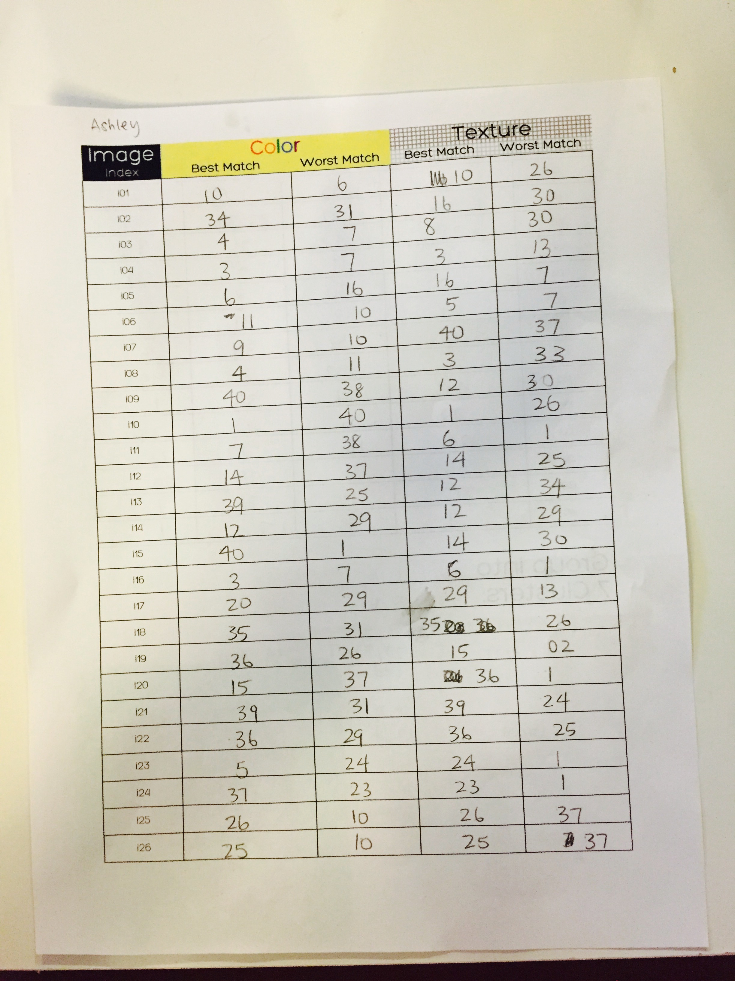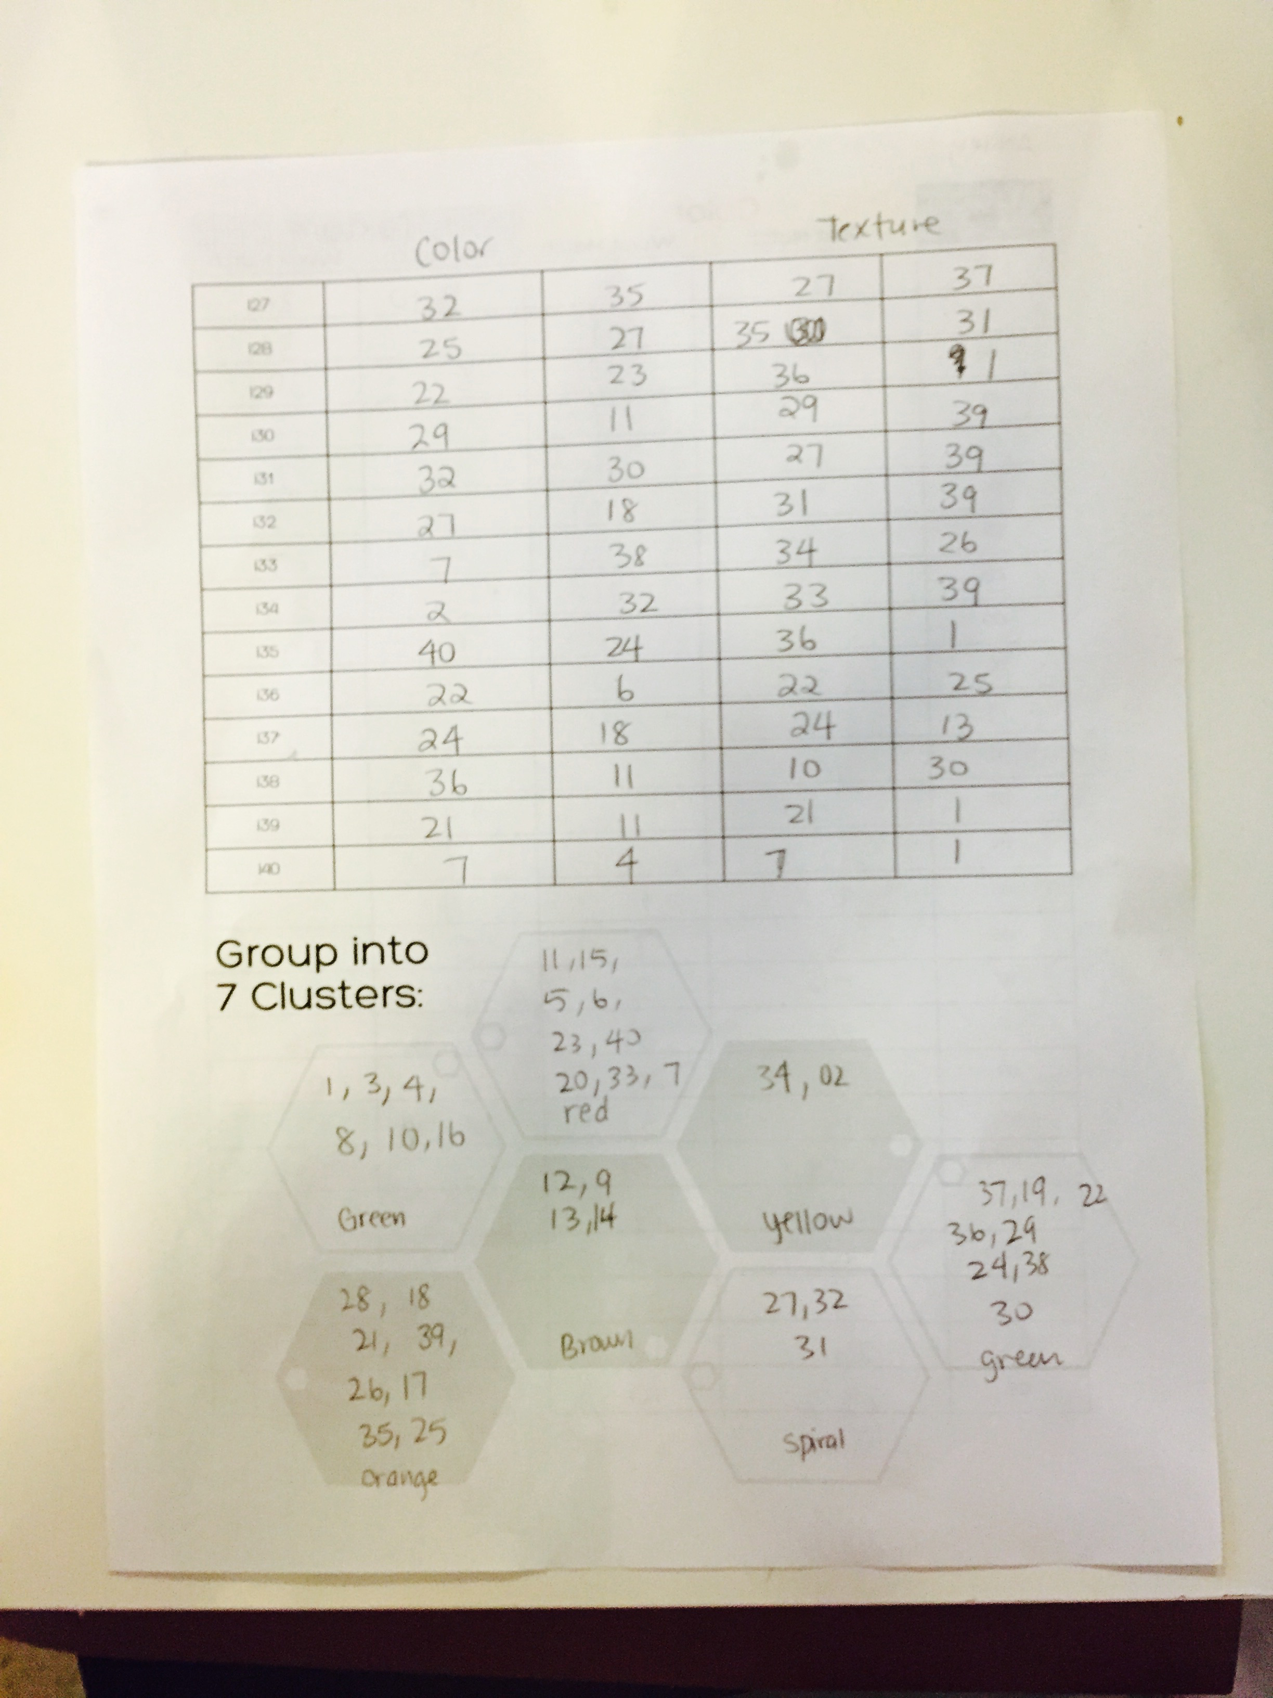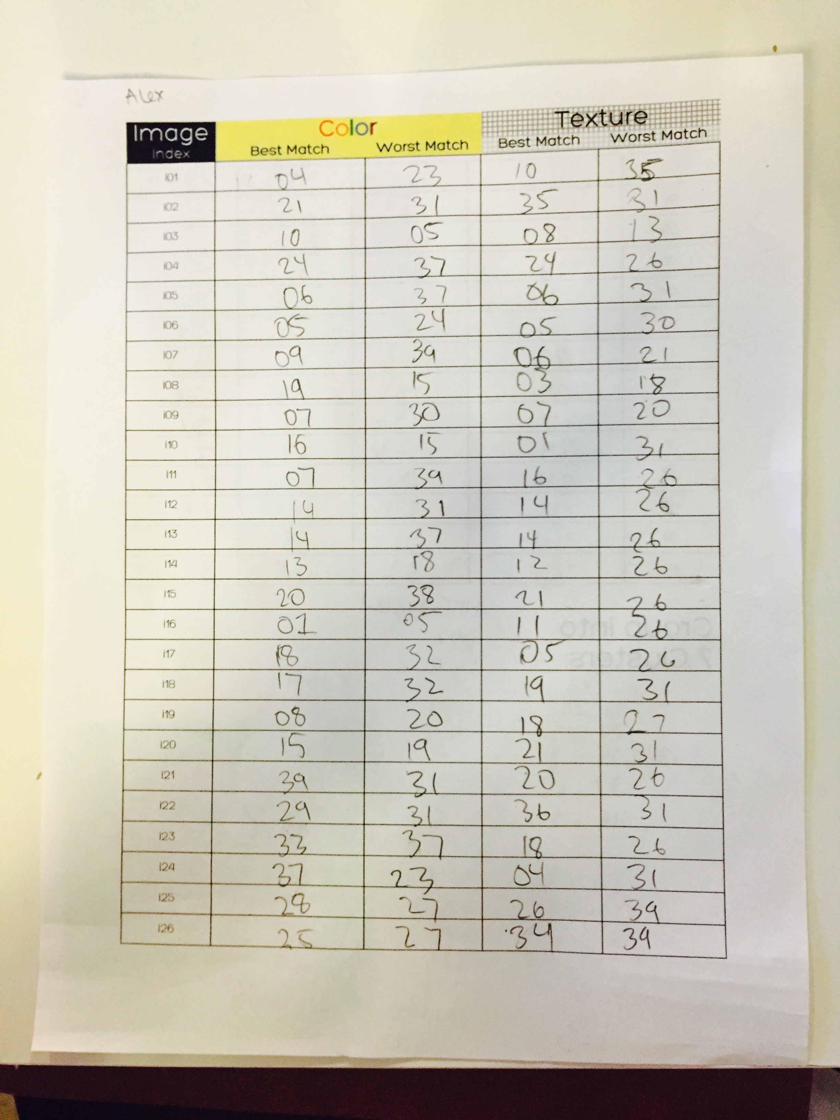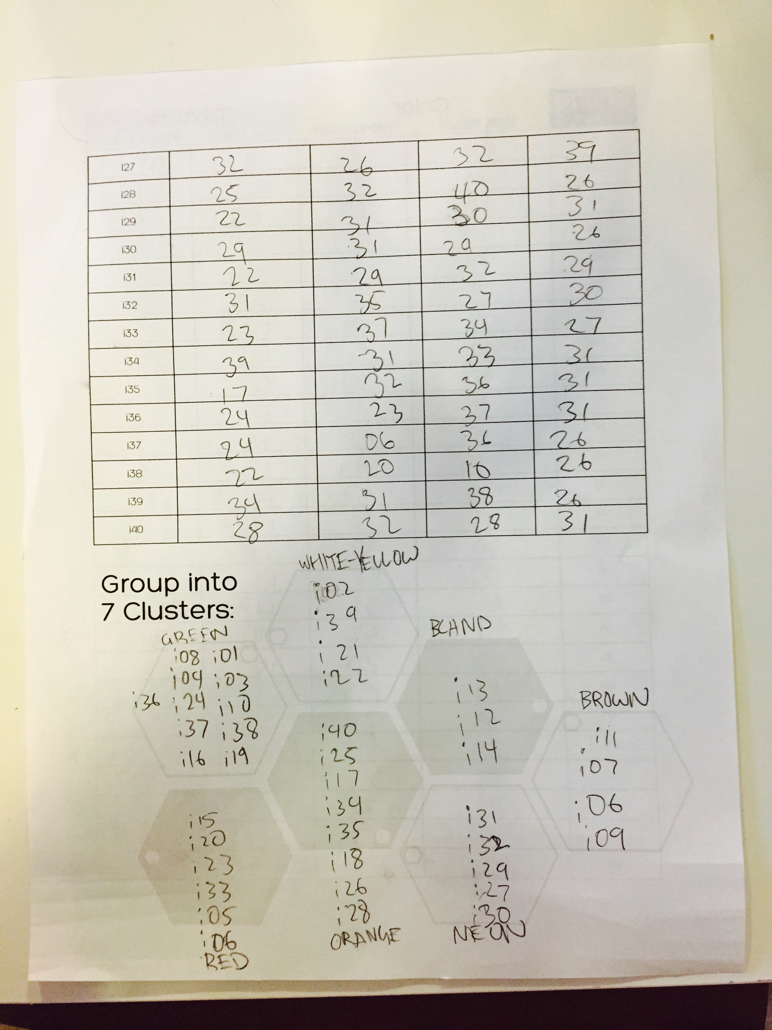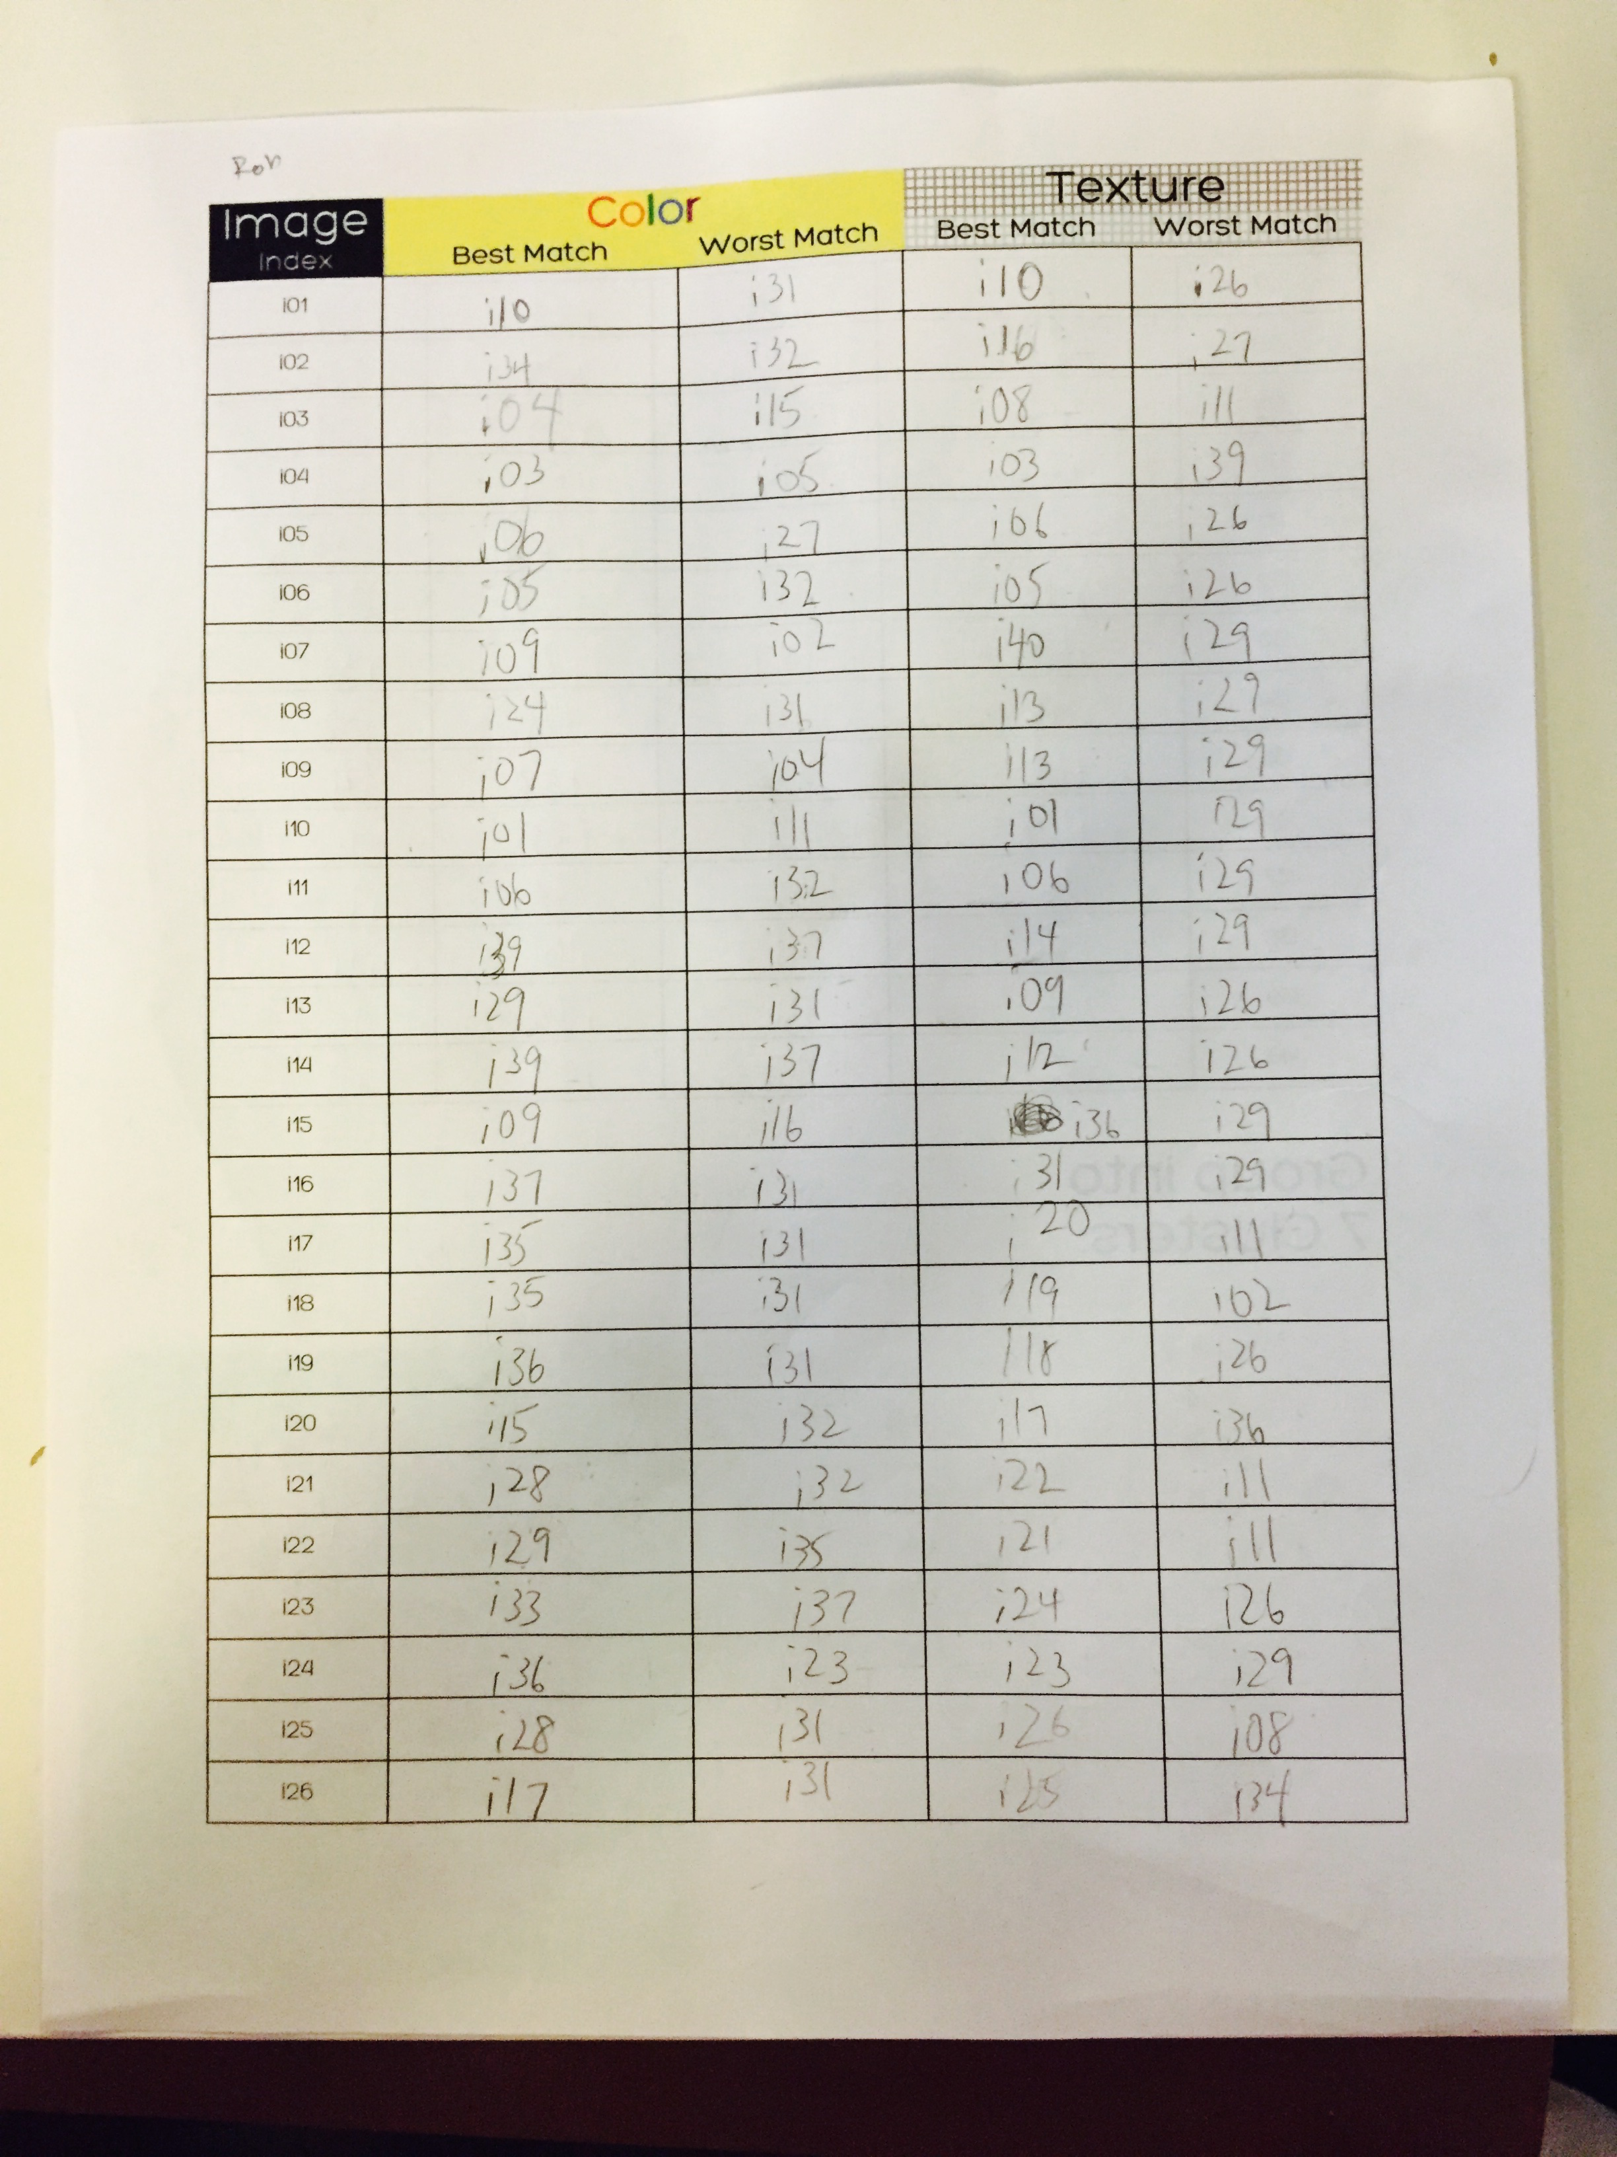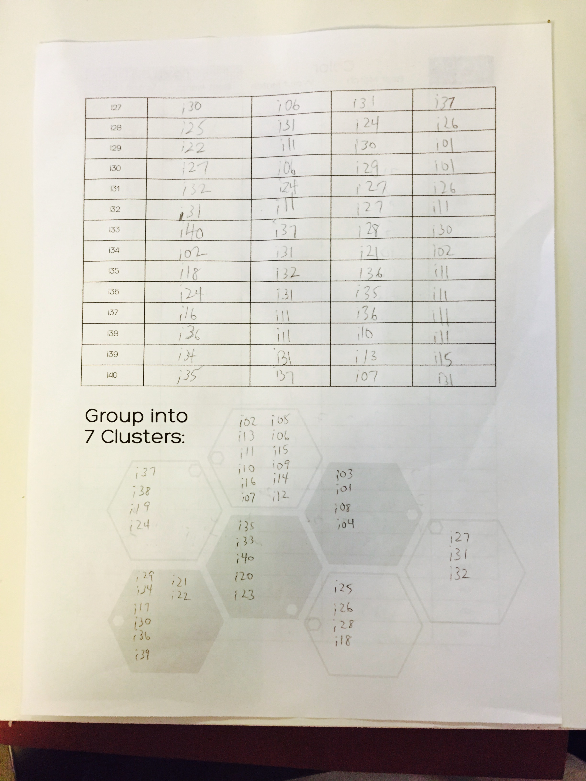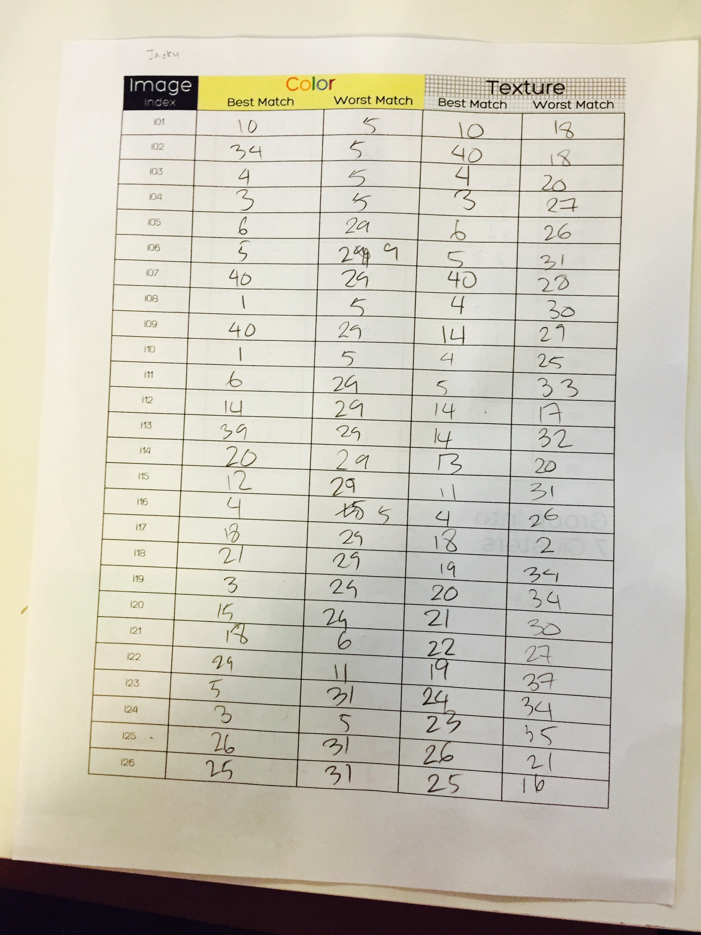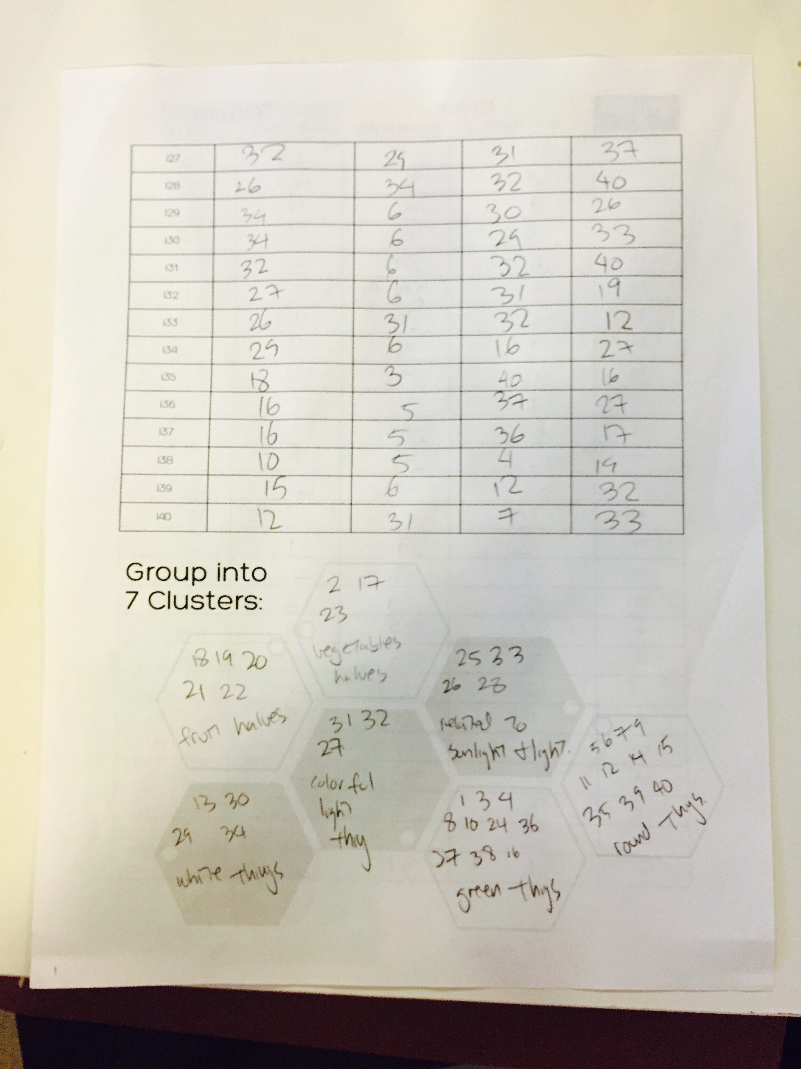

## Appendix B: Septuples + Color Histograms

|  |  |  |  |  |  |  |
| --- | --- | --- | --- | --- | --- | --- |
| Original | Most Like | 2nd Most Like | 3rd Most Like | 3rd Most Unlike | 2nd Most Unlike | Most Unlike |

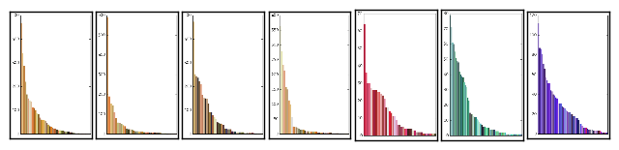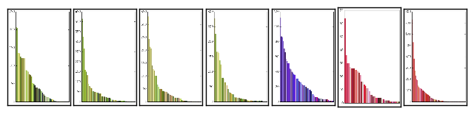

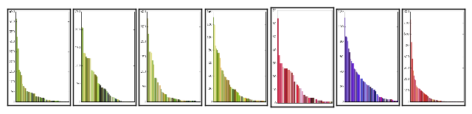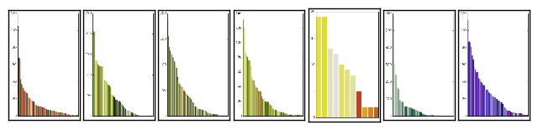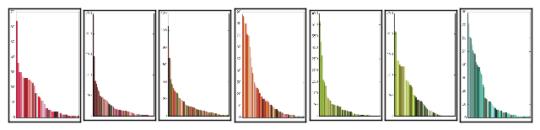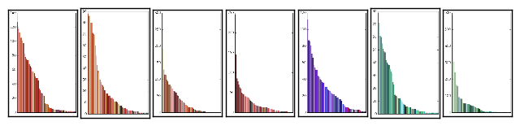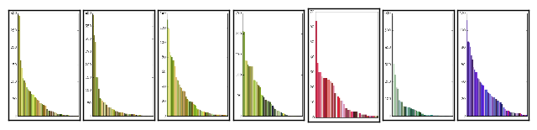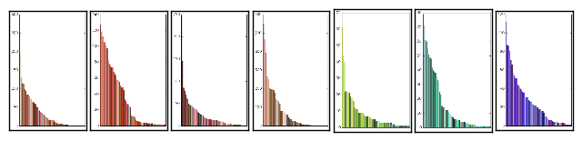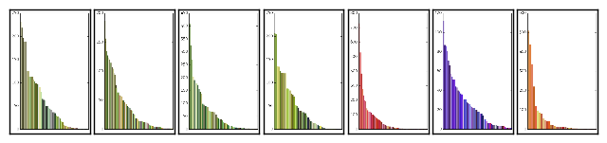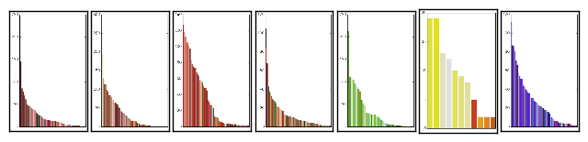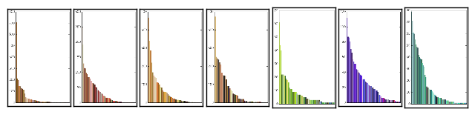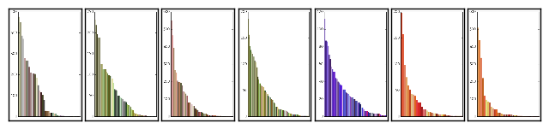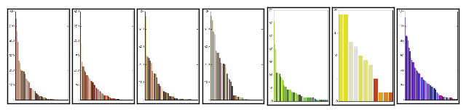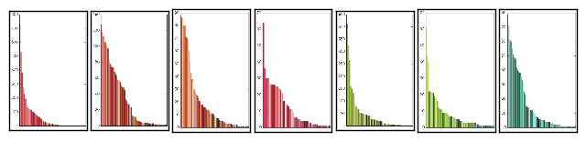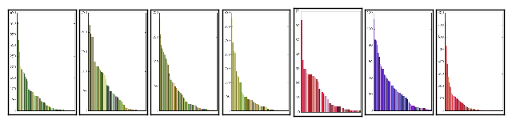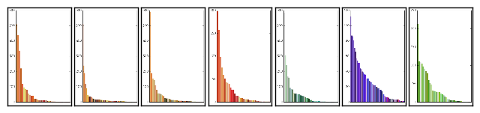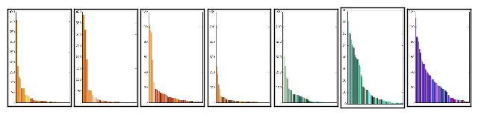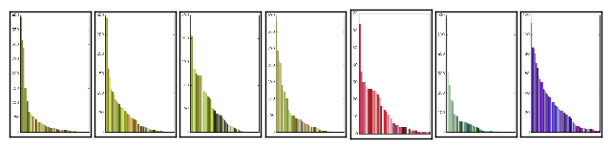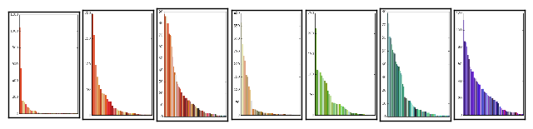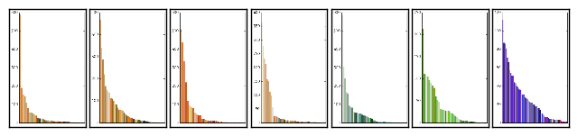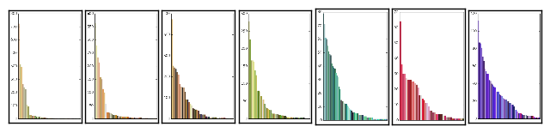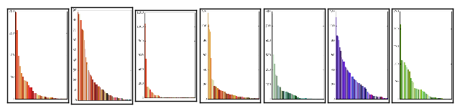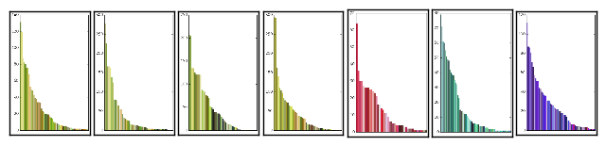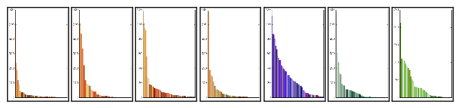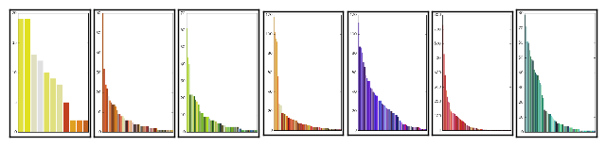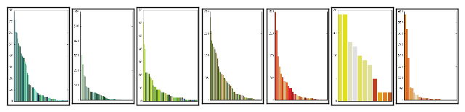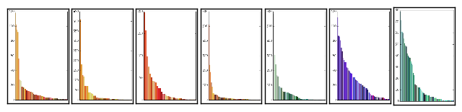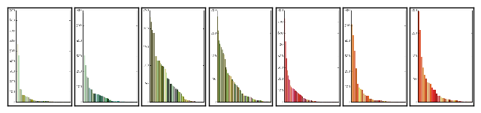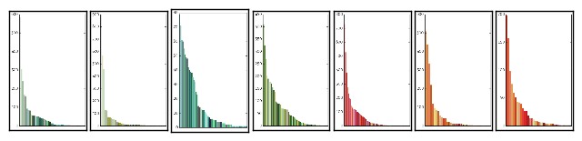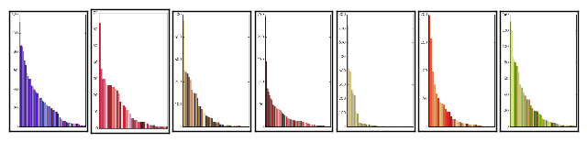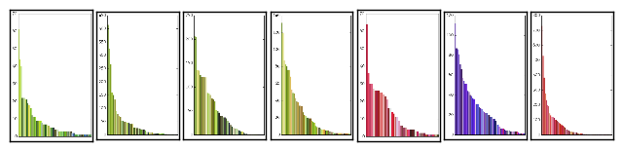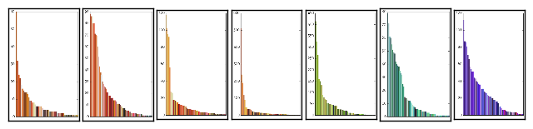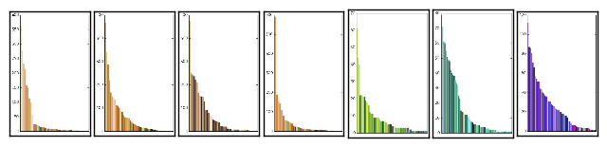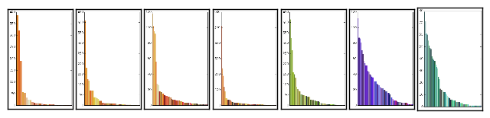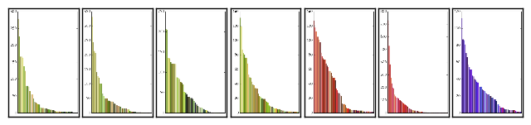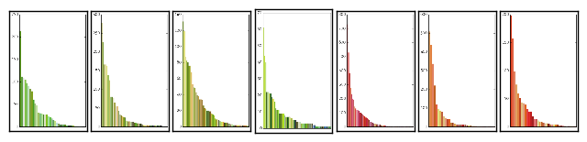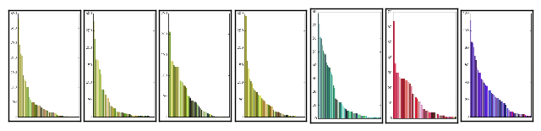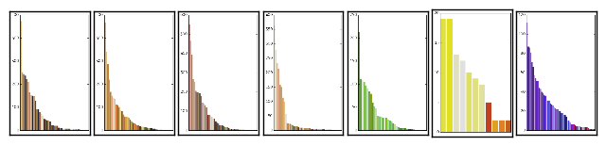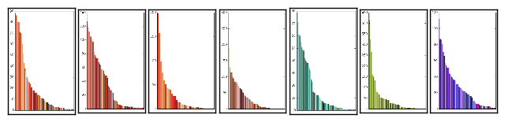

## Appendix B: Septuples + Laplacian Images

## 

## 

## 

## 

## 

## 

## 

## 

## 

## 

## 

## 

## 

## 

## 

## 

## 

## 

## 

## 

## 

## 

## 

## 

## 

## 

## 

## 

## 

## 

## 

## 

## 

## 

## 

## 

## 

## 

## 

## 

## 

## 

## 

## 

## 

## 

## 

## 

## 

## 

## 

## 

## 

## 

## 

## 

## 

## 

## 

## 

## 

## 

## 

## 

## 

## 

## 

## 

## 

## 

## 

## 

## 

## 

## 

## 

## 

## 

## 

## 

## 

## 

## 

## 

## 

## 

## 

## 

## 

## 

## 

## 

## 

## 

## 

## 

## 

## 

## 

## 

## 

## 

## 

## 

## 

## 

## 

## 

## 

## 

## 

## 

## 

## 

## 

## 

## 

## 

## 

1. Note that counting all combinations of four elements created 91,390 entries. Though it could have been worse, as I considered order not to matter, and did not recalculate (a,b,c,d) and (d,c,b,a). Also, I did not have to recalculate the distances and could just use my lookup dictionary.